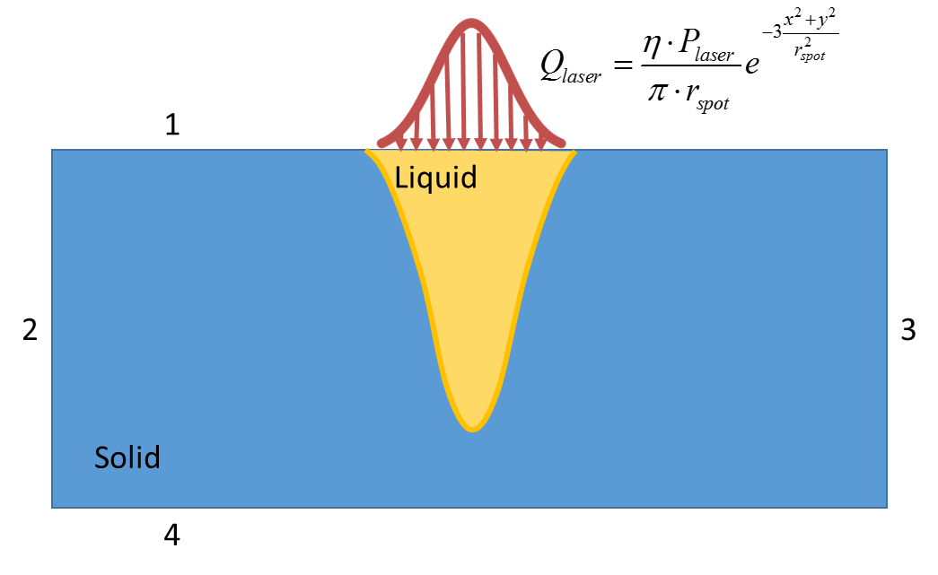

|  |  |  |  |
| --- | --- | --- | --- |
| Boundary Number | 1 | 2,3 | 4 |
| Heat Transfer |  |  |  |
| Fluid Flow |  |  |  |
| Moving Mesh |  |  |  |





 

|  |  |
| --- | --- |
| Governing Equation | Whole Domain |
| Heat Transfer |  |
| Fluid Flow |  |
| Continuity Equation |  |