July 1, 2014 09:18, Support Case 1471417
I have found a model demonstrating how this can be done. The difficulty was that there is no in-built way of defining an anisotropic BH curve. However, it is possible to tweak the governing equations so that the nonlinear material exhibits a remanent flux density in a prescribed direction. If the desired remanent flux density is Br, then we must find a coercivity Hc that corresponds to Br on the BH curve (i.e. Hc such that Br = BH(Hc)). If the BH curve is then shifted by Hc to the left, we have a new BH curve that corresponds to a nonlinear material with a flux density of Br when H = 0. As this approach is new to me, I have attached a couple of screenshots that will hopefully help me describe the procedure.
The first one shows the shift in the BH curve described above. To implement this, we need to manually alter the expression for H in COMSOL Multiphysics: if H = -grad(Vm) by default (and definition of the scalar potential), then we want to change this to H = -grad(Vm) + Hc. Hopefully, Hc will be a vector that is parallel to a coordinate axis, so we can implement this change with a single alteration to the equations, shown in the second screenshot.
I've also attached the model file which demonstrates this. There is one other slight change in the model: in the constitutive relation for the permanent magnet, the magnetic flux density norm is not taken from the material properties (i.e. there is no nonlinear material with an in-built BH curve). Instead, |B| is manually defined as int1(sqrt(mfnx.Hx^2+mfnx.Hy^2)), where int1 is the BH interpolation. The result is the same, but behind the scenes this alternative approach leads to a more stable formulation of the nonlinear problem.
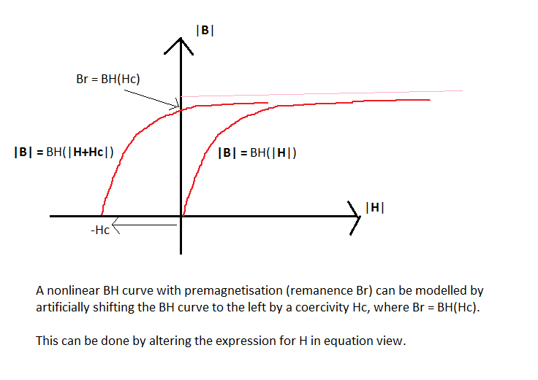
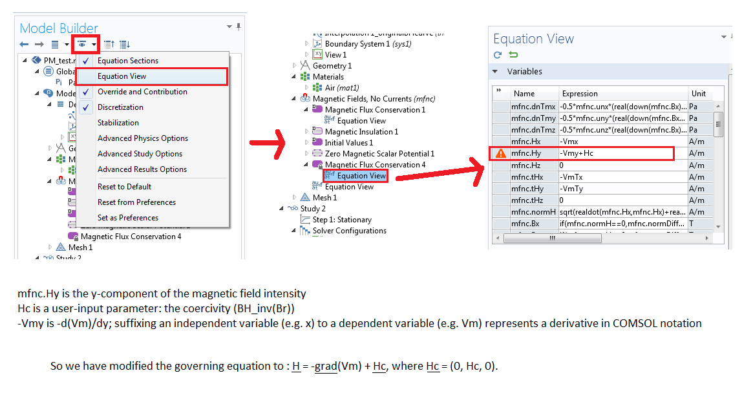

Please let me know if you have any further questions on this model.

