Doubts regarding Comsol Multiphysics

- A 3d transient model to understand the effect of combined Buoyancy-Marangoni convection in a cylindrical geometry is presented . In the below model shown in Fig 1, we want to apply the cylindrical coordinates (r, θ, a)

Fig 1: Schematic of the system
As a solution to this, we have changed the default cartesian system (x, y,z) to cylindrical coordinates under component< definitons<cylindrical coordinates.

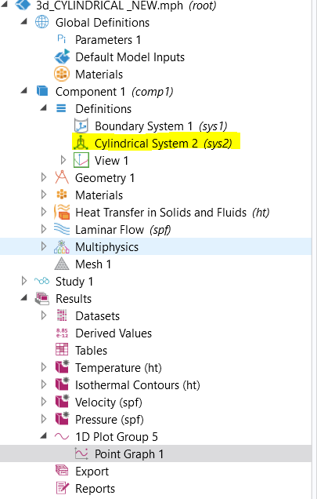
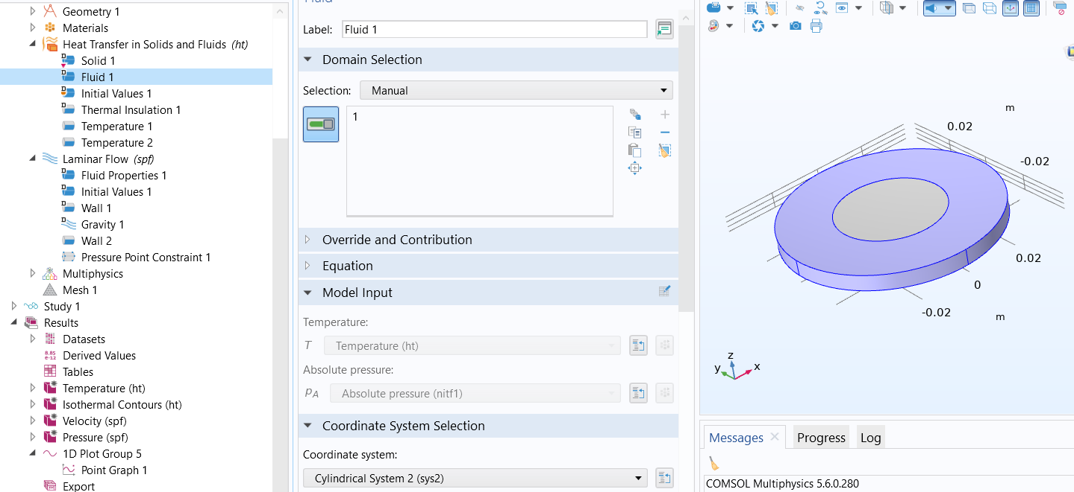
Fig 2: Applied cylindrical system in the problem

But while postprocessing we are unable to get the resullts in (r, θ, a) coordinate systems.
Eg: If we want to take the azimuthal velocity ie V_{θ,} in the drop down only cartisean variables are available ie V_{x}, V_{y}, V_{z}.
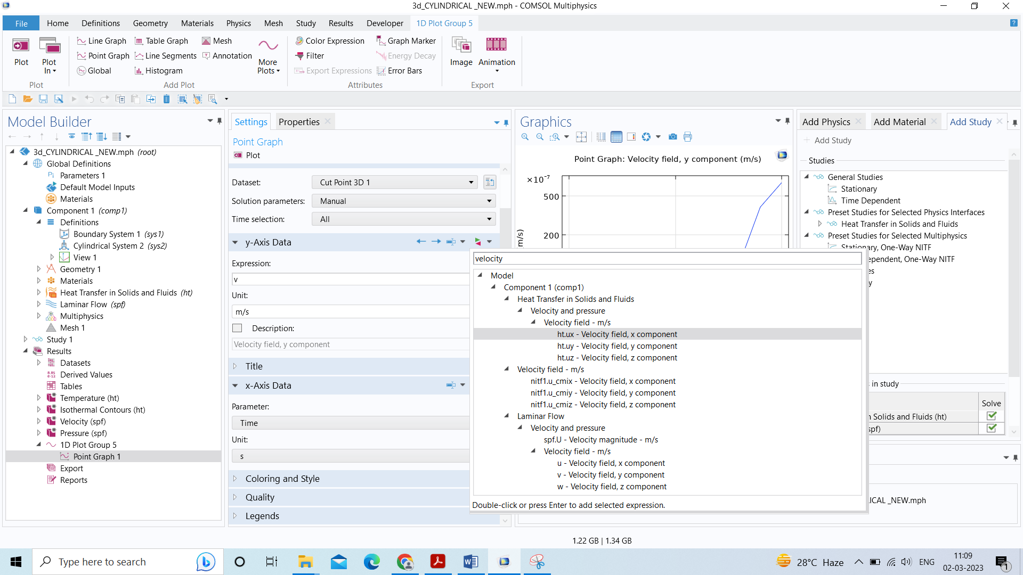

Fig 3: Post processing with dropdown menu

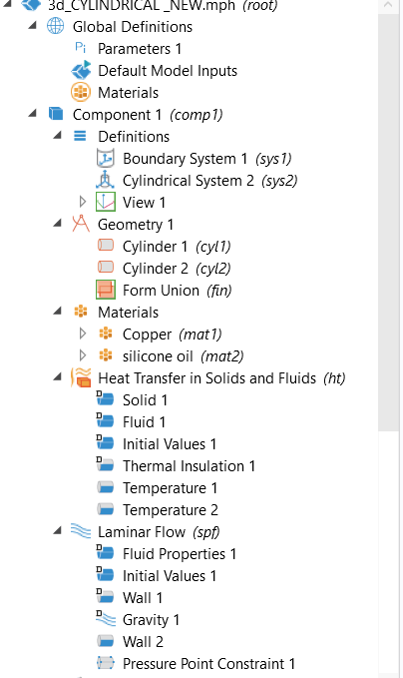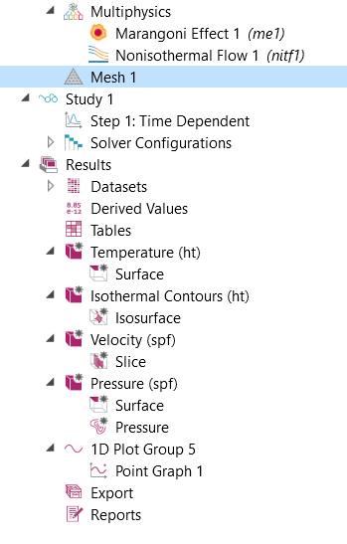
Fig 4: Expanded tree
- We are applying rotation to a similar system and followed the tutorials but the plots are found to be empty. Can you please suggest me where we are doing it wrong?

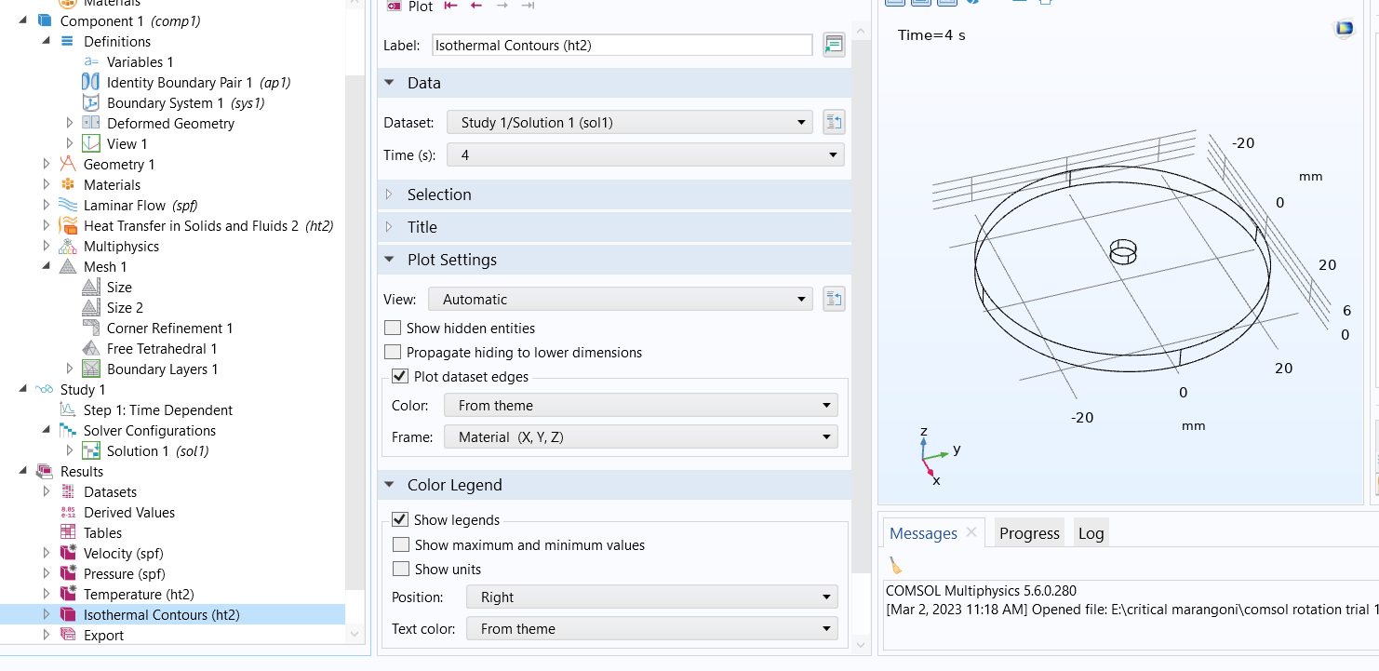
Fig: 1 Empty plots

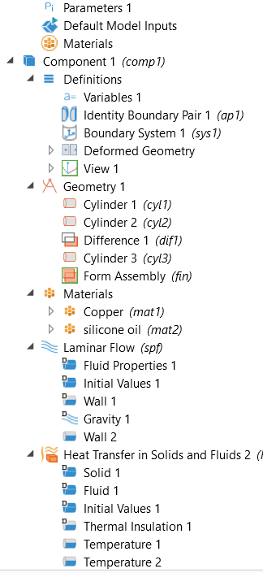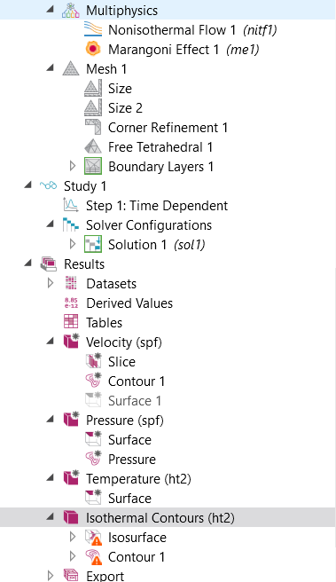
Fig 2: Expanded tree

