First, determine your points of interest from your model.
In Excel, type in the values where the first column is x and the second column is y. DO NOT put in any other information.
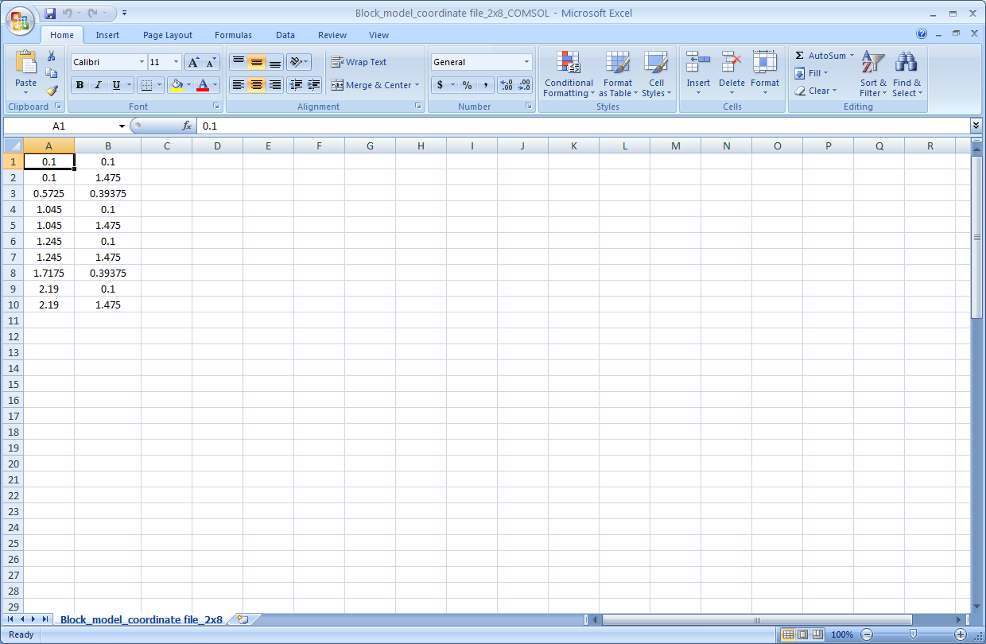
Select “Save As,” type in your file name and change the file type to “Text (tab delimited)”
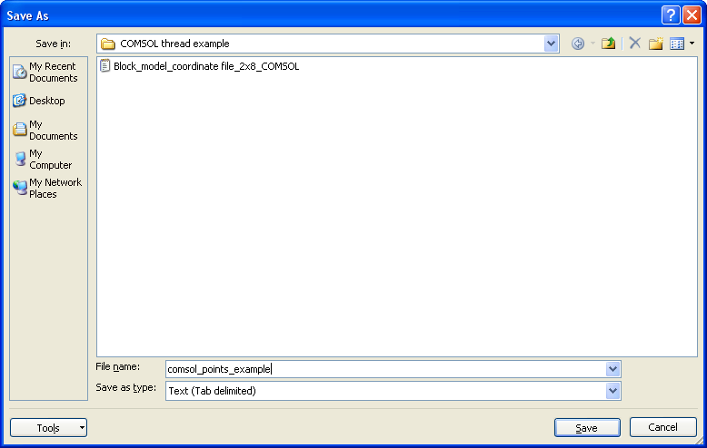
For me, an error pops up:
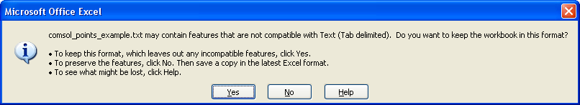
But it doesn’t matter what I’ve selected, as the text file has already been made. I still selected “Yes.”
Check your text file:
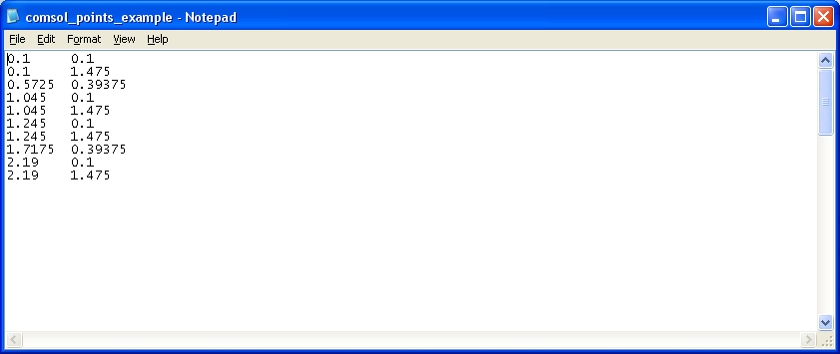
Now, I can use this file in COMSOL.

