1. Global Definitions --------Parameters: T0=273.15+22.5[K], patm=1[atm]
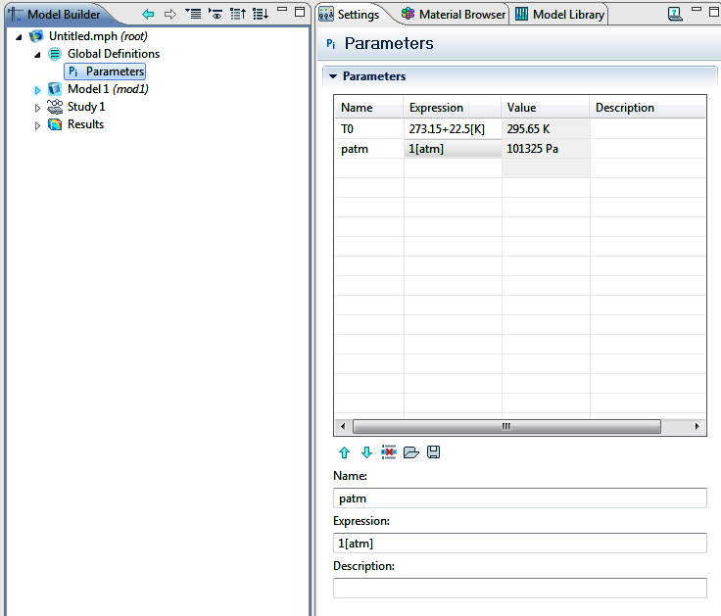
2. Model Definitions--------Variable: rho_ref=mat1.def.rho(patm[1/Pa],T0[1/K])[kg/m^3]
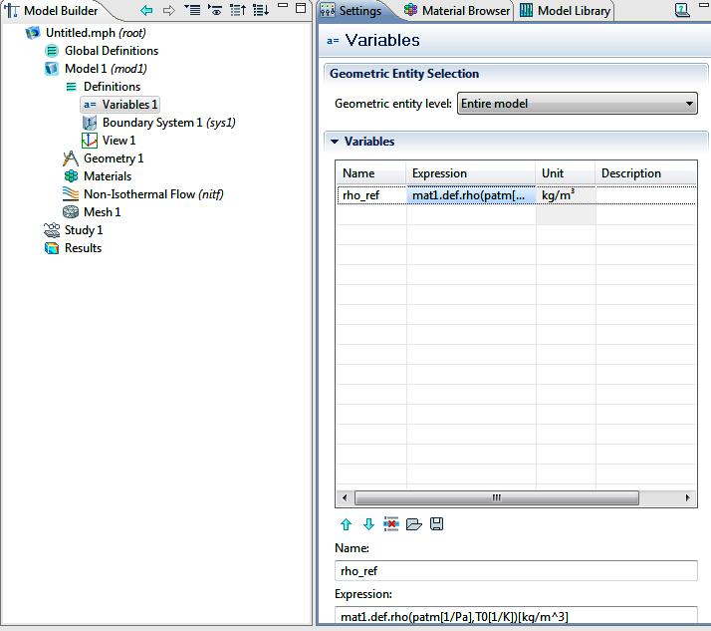
3. Geometry--------Block1 (air block): width=0.8m, Depth=0.8m, Height=0.8m
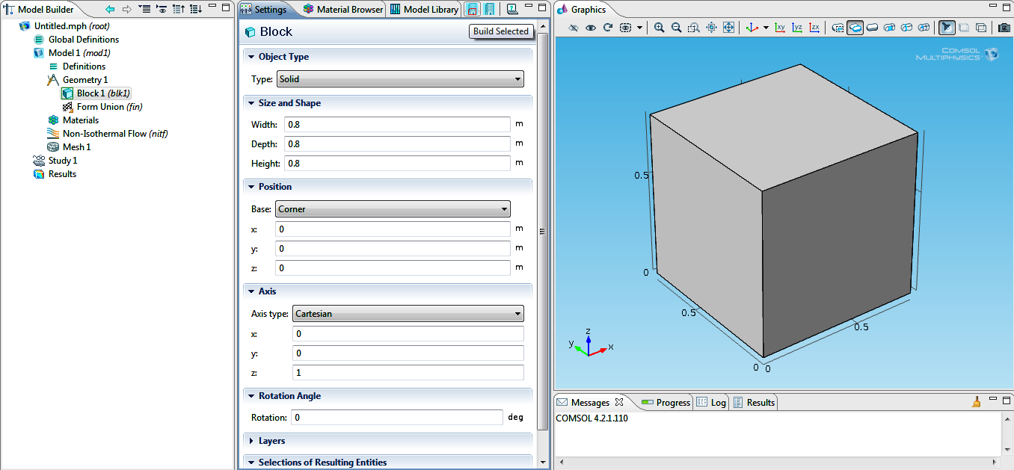
Block 2 (Hot Plate): width=depth=0.8m, Height=0.005m
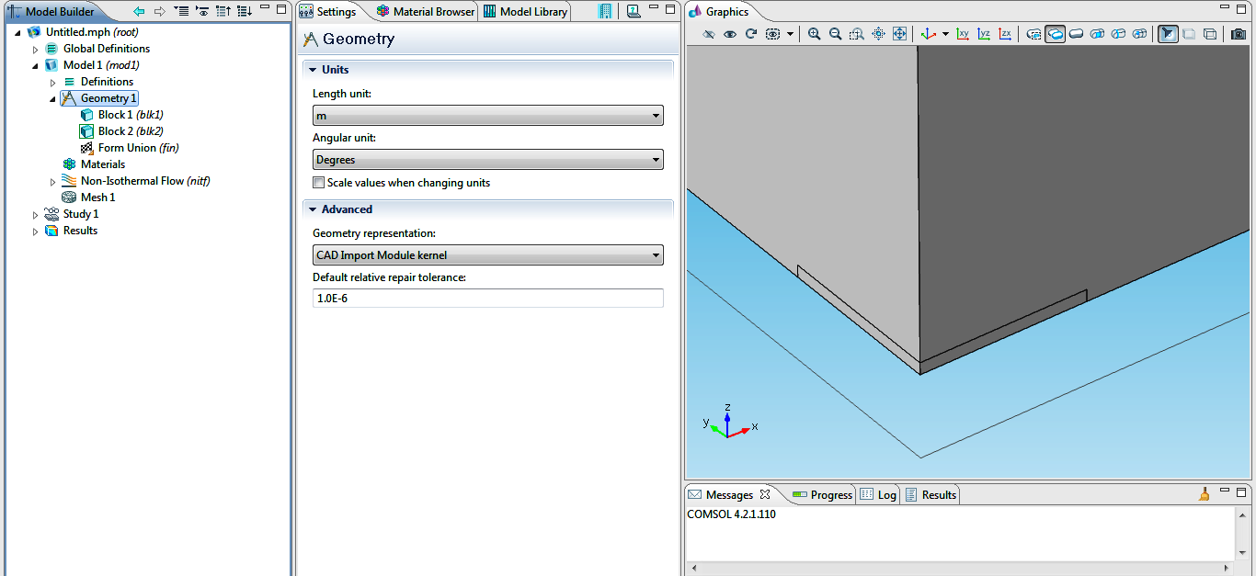
Boolean operation-------Difference
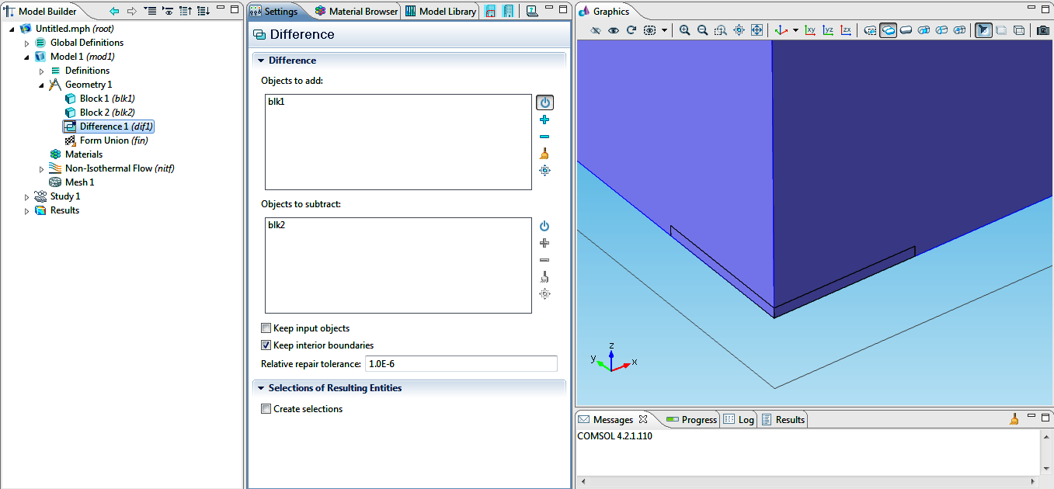
4. Material--------Air---------All Domains
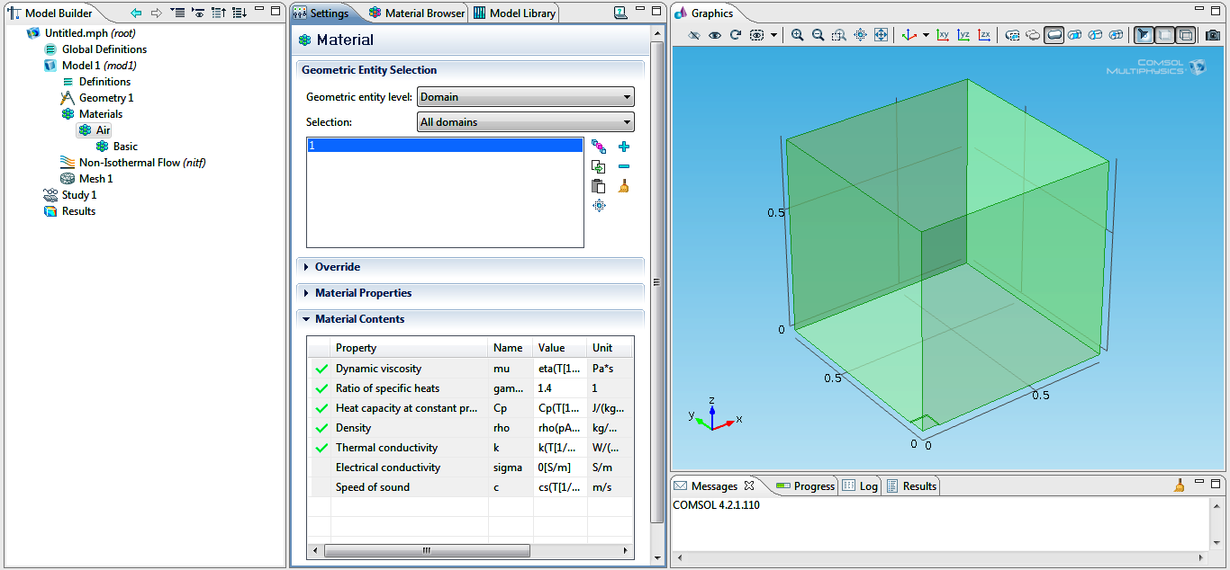
5. Non-Isothermal Flow (nitf) --------------- Fluid (All Domains)
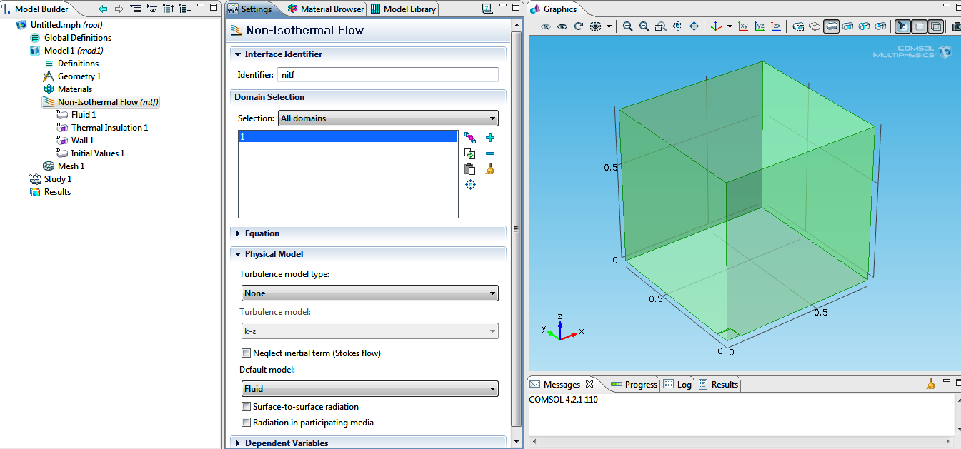
6. Fluid 1----------------All Domains--------------------P:User Defined (=1[atm])
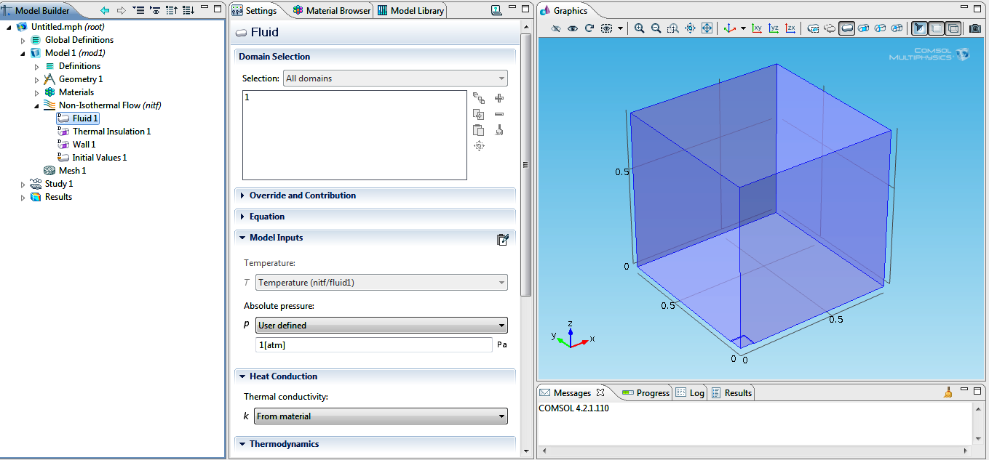

7. Initial Values--------------------u_{z}= 0.01 m/s, P=0, T=T0
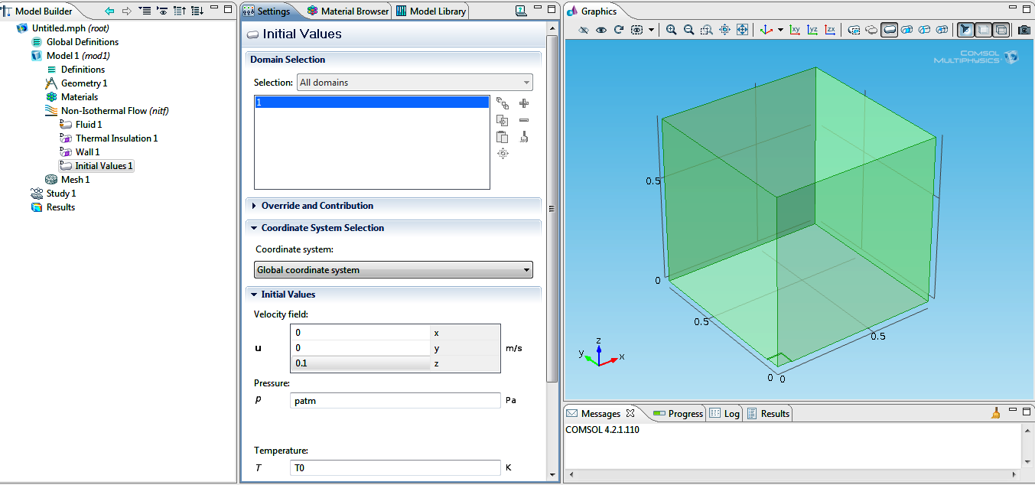
* In the final trial I changed P=0 and u=0.01m/s.
8. Volume Force (Laminar Flow)---------------F_{z}=-g*(nitf.rho-rho-ref)
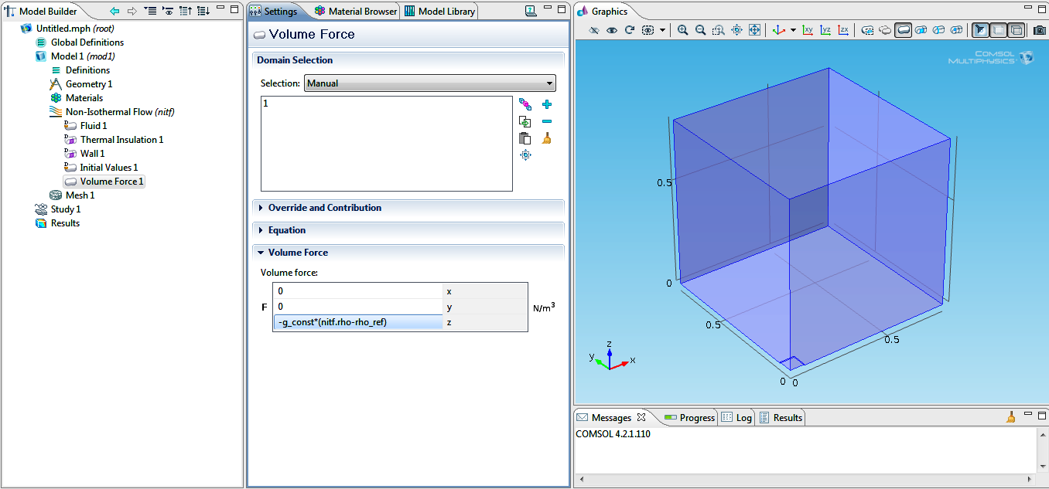
9. Laminar Flow----------Symmetry1----------1&2
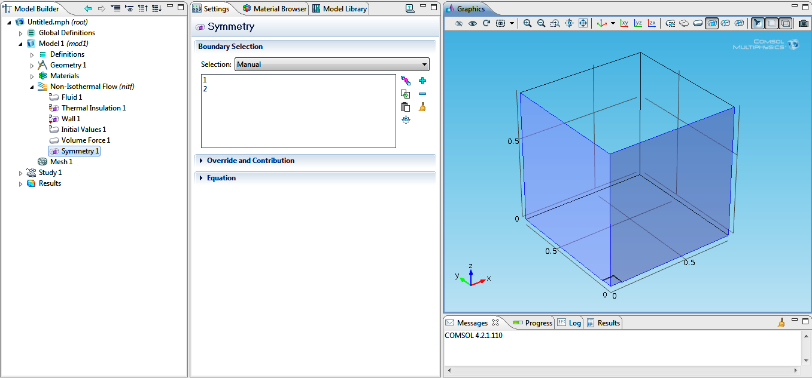
10. Heat Transfer------------Symmetry2-----------1&2
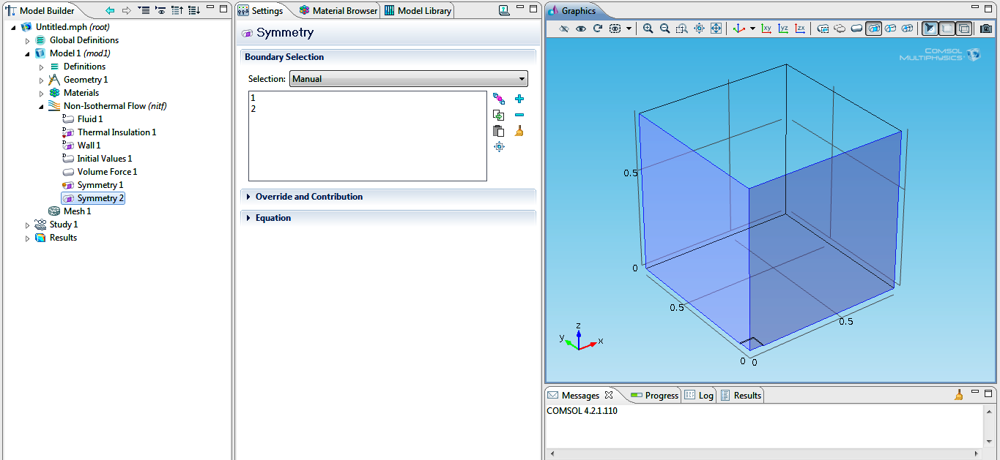
11. Open Boundary 1--------------------f₀=0, T₀=0----------------------------7&9
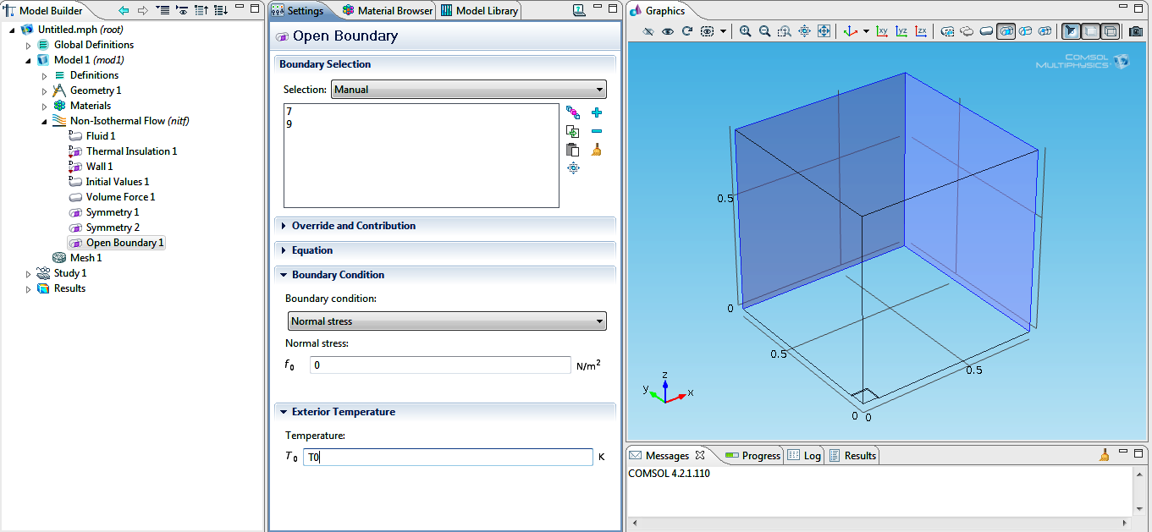
12. Laminar Flow------------Outlet (Pressure, no viscous stress)-----p₀=0----------4
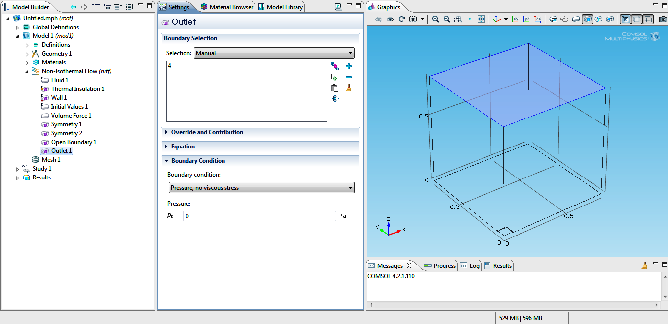
13. Heat Transfer------------Outflow-------------4
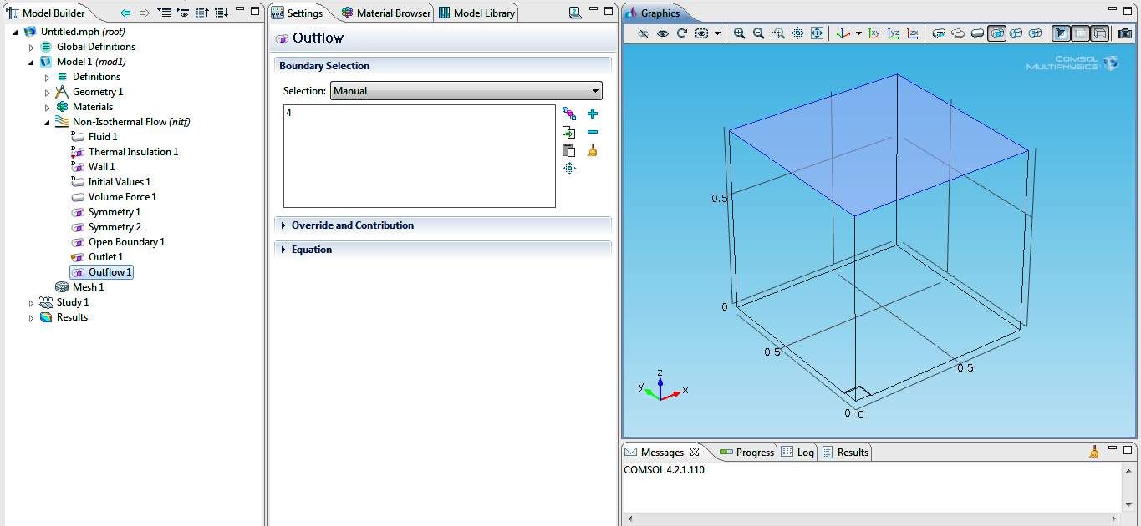
14. Laminar Flow----------Wall (Slip)--------------6
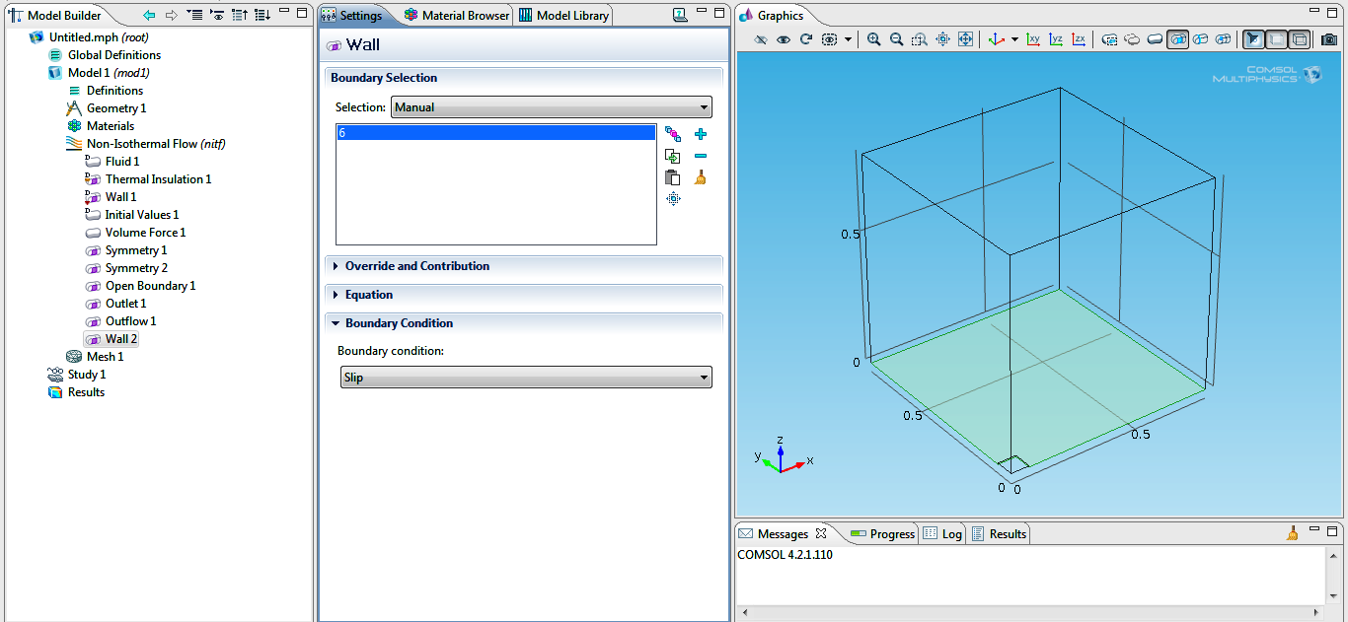
15. Heat Transfer--------------------Temperature1 (T=T₀)--------------------6
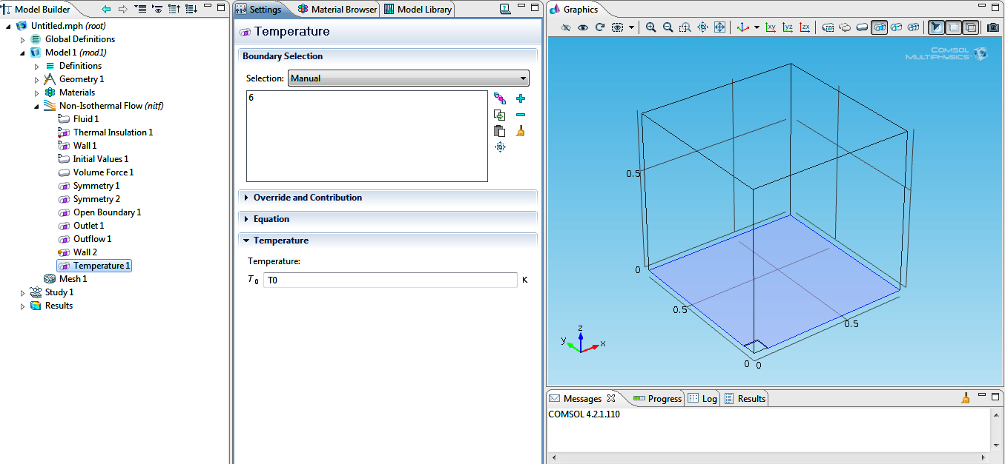
16. Heat Transfer----------------Temperature2 (T=423.15K=150ºC)-------------------3
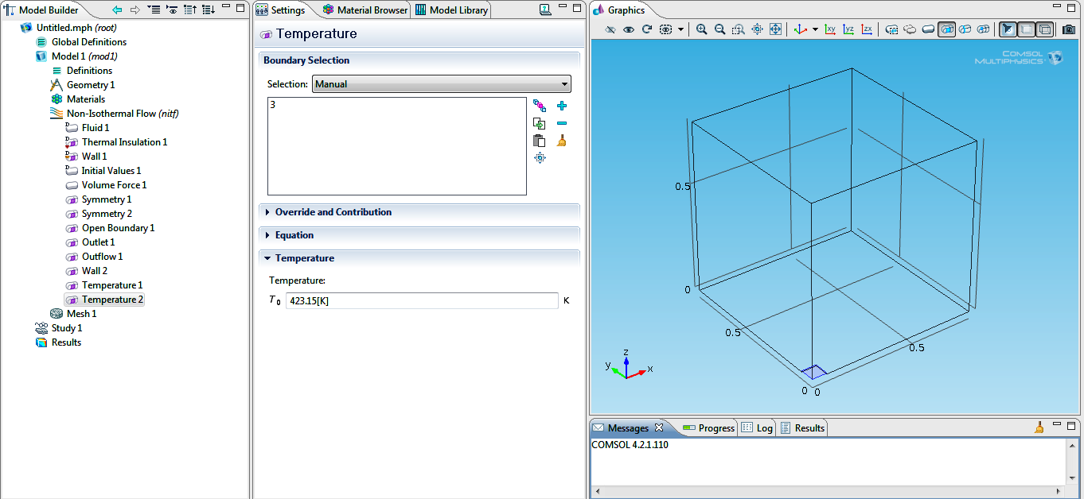
17. Pressure Point Constraint------------------P₀=0----------------------------12
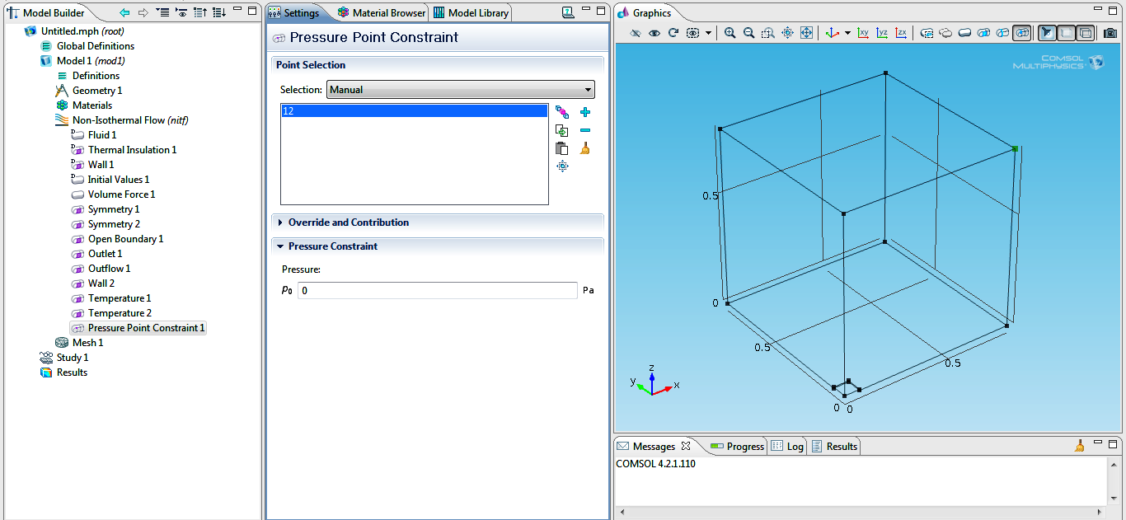
18. Mesh------------------------Edge--------------------Fine-----------------------1,2,3,6,7,8,9,13
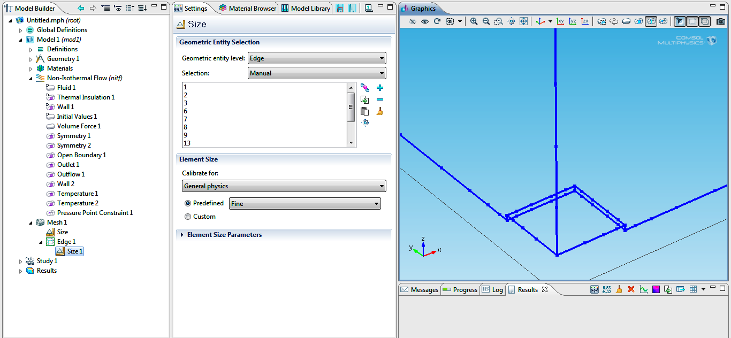

19. Mesh-----------------Remaining (Entire Geometry)----------------------Coarser
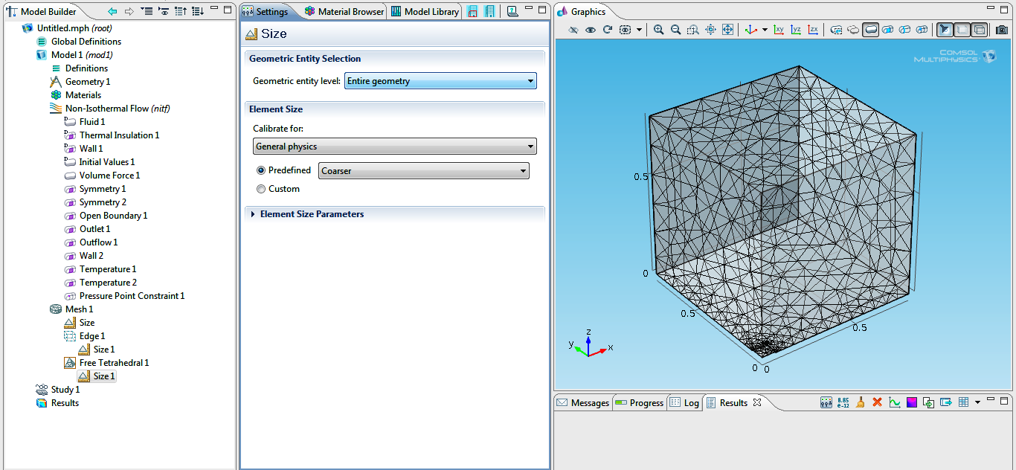
20. Study------------------Solver Configurations------------------Stationary Solver------------------Fully coupled---------------Automatic highly non-linear------------------No of iterations: 300
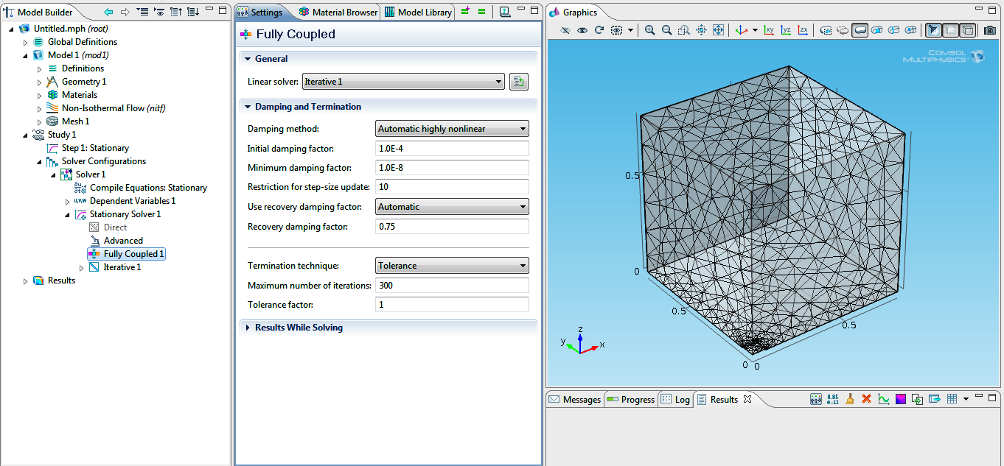
21. Results-------------------------Convergence plot
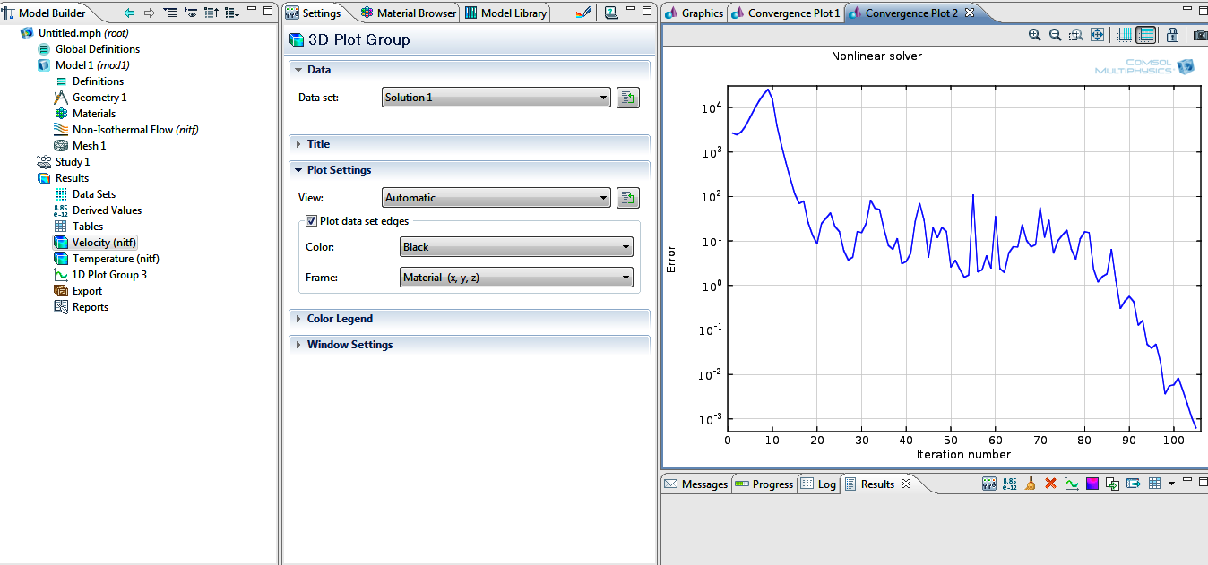
22. Results--------------------Temperature & Velocity Field (Arrow)
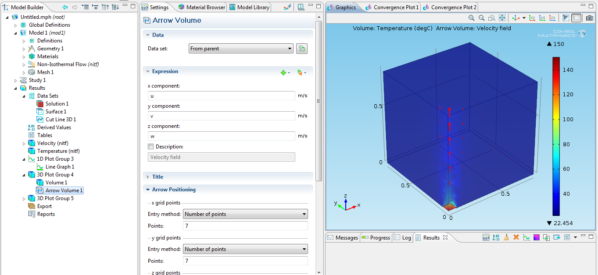
23. Results---------Monitoring Temperature changes with distance (z) from the plate
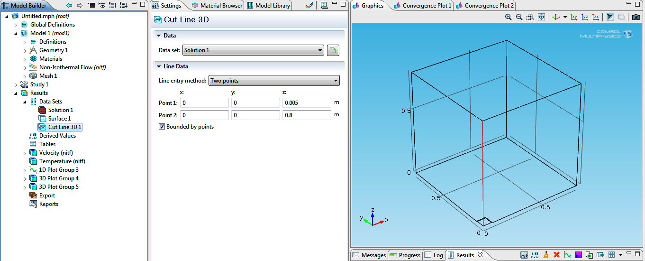
Temperature changes with the distance from the center point of the hot plate
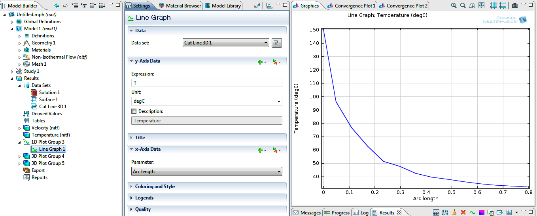

The above graph shows how temperature of the surrounding air changes as we get further from the plate surface. Due to this prediction when we get 80 cm above the plate the temperature reduces to a value close to 30 degC, however due to experiment we will have room temperature (23 deg C) at 30 cm above the plate where the model predicts the temperature to be 20 degC higher close to about 50 degC.

