COMSOL, Inc.  100 District Avenue  Burlington, MA 01803 USA  Phone: +1 781-273-3322  Web: www.comsol.com  Blog: www.comsol.com/blogs | Media Contact:  Natalia Switala, PR & Communications Manager  natalia@comsol.com  About the Application Builder and COMSOL Server™

Simulation Apps Provide Graduates with a Competitive Advantage

The Application Builder available in COMSOL Multiphysics® is being used in universities worldwide to introduce students to multiphysics software solutions that better prepare them for the workforce.

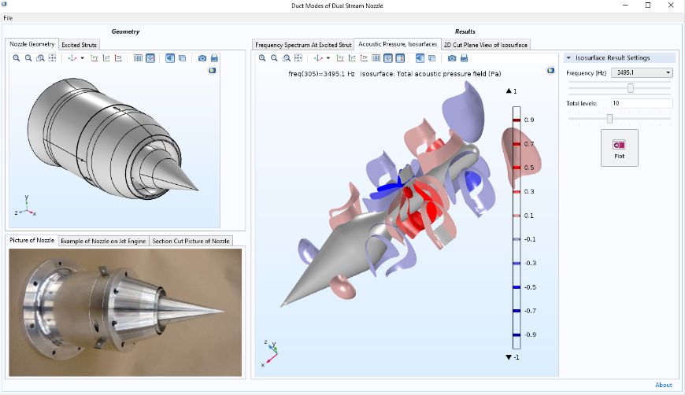
BURLINGTON, MA (August 13, 2018) — Engineering and science educators are aware that prospective employers are seeking graduates with skills using product design and simulation software. To address this need, one professor at the University of Hartford has pioneered the use of simulation apps by undergraduate students in the mechanical engineering program. The apps provide students with easy-to-use specialized user interfaces to run realistic simulations and visualize results without any previous training. This inquiry-based learning method enables deeper understanding of the physics and theory. Students can then easily progress to learn more about the underlying model and even build their own simulation apps in the Application Builder that is available in the COMSOL Multiphysics® software.

Working with simulation apps helps students to create a narrative describing the boundary conditions and setup used in the model, as well as arrange visual data, charts, graphs, and equations. “Our students tell us that the use of simulation software has enhanced their learning and helped them to easily visualize difficult theoretical concepts without exposing them to the underlying complexity,” said Ivana Milanovic professor of mechanical engineering at the University of Hartford.
Simulation app built by undergraduate students Iliana Albion-Poles and Jeffrey Severino. Their work is supported by the Connecticut Space Grant for Faculty Research. The app predicts the appearance of tones in a dual stream 4-strut nozzle for jet engines.

Simulation apps serve as an easy entry point into numerical analysis. “Once students are familiar enough the concepts and the modeling techniques, they can eventually create their own apps using the Application Builder to further expand their knowledge and the reach of their collective analysis capabilities,” concludes Milanovic.

To learn more from Ivana Milanovic join us for her keynote at the COMSOL Conference 2018 in Boston.

About COMSOL
COMSOL is a global provider of simulation software for product design and research to technical enterprises, research labs, and universities. Its COMSOL Multiphysics® product is an integrated software environment for creating physics-based models and simulation apps. A particular strength is its ability to account for coupled or multiphysics phenomena. Add-on products expand the simulation platform for electromagnetics, structural, acoustics, fluid flow, heat transfer, and chemical applications. Interfacing tools enable the integration of COMSOL Multiphysics® simulations with all major technical computing and CAD tools on the CAE market. Simulation experts rely on the COMSOL Server™ product to deploy apps to their design teams, manufacturing departments, test laboratories, and customers throughout the world. Founded in 1986, COMSOL employs more than 450 people in 19 offices worldwide and extends its reach with a network of distributors.
~
COMSOL, COMSOL Multiphysics, LiveLink, and COMSOL Server are either registered trademarks or trademarks of COMSOL AB. For other trademark ownership, see www.comsol.com/trademarks.

