Announcing COMSOL Days 2021: 40+ Online Events on Multiphysics Simulation
COMSOL announces COMSOL Days 2021 with more than 40 online events planned on a range of engineering and science topics.
BURLINGTON, MA (March 4, 2021) — COMSOL is excited to announce COMSOL Days 2021. These 1-day virtual events feature live technical presentations, keynote talks from invited speakers, and panel discussions focused on using multiphysics modeling and simulation to accelerate product development and advance research. Parallel tracks cover the latest news in COMSOL Multiphysics® and include sessions for attendees who are looking to understand how simulation, and the creation and deployment of specialized apps, can benefit their organization. In interactive Tech Cafés on specialized topics, COMSOL application engineers and technical product managers will share modeling best practices and field questions from COMSOL users and attendees on their simulation projects. COMSOL Day attendance is free of charge.
Jeanette Littmarck, sales director at COMSOL and project leader for COMSOL Days, says: "We have found that the online format is convenient and efficient for many, and we are really happy about the activity level at these events. Attendees are participating in discussions, and ask a lot of great questions. And according to attendee feedback, COMSOL Days are providing the great experience that we strive to provide."
More than 40 online COMSOL Day events are planned for 2021 and cover a wide range of application areas, including:
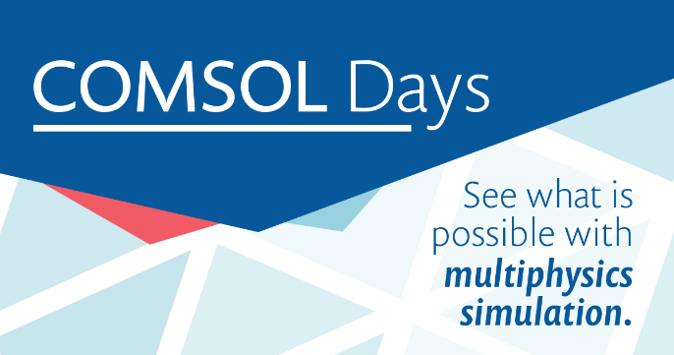
- Engineering education and research
- MEMS
- Batteries
- Optics and photonics
- Biomedical applications
- Acoustics
- Vehicle electrification
- AC/DC
- Heat transfer in material processing

A number of COMSOL Days cater to a geographic region, with guest speakers from the local simulation community. One example is COMSOL Day Canada, where COMSOL is teaming up with CMC Microsystems. CMC manages Canada’s National Design Network® and makes the COMSOL® software easily accessible to researchers in their network. Owain Jones, CAD manager at CMC and guest speaker at COMSOL Day Canada, said, “Cohosting this event is a great way for COMSOL and CMC to service the Canadian microsystems R&D community. Our members can connect with both CMC and COMSOL, ask questions, and learn about topics that are relevant to their work.”
Events that are open for registration are listed here: COMSOL Days 2021. The list of events will be updated throughout the year.
About COMSOL
COMSOL is a global provider of simulation software for product design and research to technical enterprises, research labs and universities. Its COMSOL Multiphysics® product is an integrated software environment for creating physics-based models and simulation apps. A particular strength is its ability to account for coupled or multiphysics phenomena. Add-on products expand the simulation platform for electromagnetics, structural, acoustics, fluid flow, heat transfer and chemical applications. Interfacing tools enable the integration of COMSOL Multiphysics® simulations with all major technical computing and CAD tools on the CAE market. Simulation experts rely on COMSOL Compiler™ and COMSOL Server™ to deploy applications to their design teams, manufacturing departments, test laboratories and customers throughout the world. Founded in 1986, COMSOL has 19 offices worldwide and extends its reach with a network of distributors.

COMSOL and COMSOL Multiphysics are registered trademarks or trademarks of COMSOL AB. Canada’s National Design Network is a registered trademark of Canadian Microelectronics Corporation / Société canadienne de micro-électronique operating as CMC Microsystems. For other trademark ownership, see www.comsol.com/trademarks.

