COMSOL, Inc.
1 New England Executive Park, Ste 350
Burlington, MA. 01803 USA
Phone: +1 781-273-3322
Fax: +1 781-273-6603
Web: www.comsol.com
E-mail: info@comsol.com

Editor contact:
Lauren Sansone
Marketing Manager
lauren.sansone@comsol.com

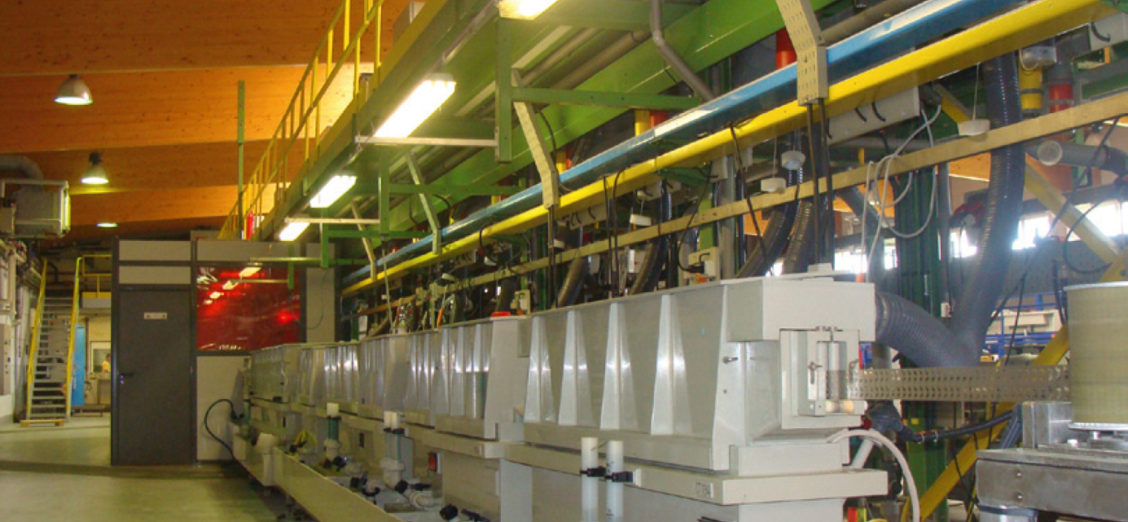

Factory floor with a series of reel-to-reel electroplating units. As reels of solid or stamped metal plates pass through the electroplating units, metal is deposited over the entire plate or sections of the plate according to the application of electric current and the placement of shields. By using COMSOL simulation software, savings of between 10% and 30% of the metal deposited during electrolysis have been achieved. Picture courtesy of Philippe Gendre, PEM, France.

New Electrodeposition Module for COMSOL Multiphysics Released

Expansion module empowers shape and composition modeling and simulation of electrodeposits for metallic electroplating, electroforming, and decorative, wear and corrosion-protective coating.

BURLINGTON, MA (June 16, 2011) — COMSOL, Inc., today announced the release of the Electrodeposition Module, a new add-on expansion module for the company's flagship product COMSOL Multiphysics. The Electrodeposition Module provides engineers the ability to model and simulate the shape and composition of electrodeposits for such processes as copper and gold electroplating in the electronics industry, wear and corrosion-protective coatings of mechanical parts, decorative coatings such as chrome and nickel plating of automotive parts, as well as electroforming of thin and complex manufactured parts.

"The Electrodeposition Module allows for very accurate descriptions of the electrochemistry, heat transfer, and fluid flow in electrochemical cells used for electrodeposition,” says Dr Henrik Ekstrom, technical program manager for electrochemical applications at COMSOL. “With this tool, developers can run realistic simulations of electrodeposition processes, from the micro-scale on up, using interfaces tailored for exactly these applications. This saves a lot of time and money in the development process."

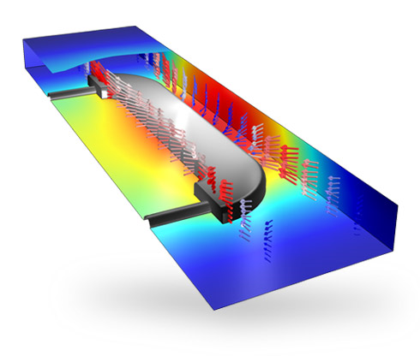
An electrodeposition simulation for predicting the thickness of the decorative deposited layer in a furniture fitting. The Electrodeposition Module computes the layer thickness, here on the order of micrometers, using a secondary current distribution model and a deposit thickness variable at each point on the surface.

The Electrodeposition Module enables realistic simulations for investigating the influence of cell and electrode geometry, chemistry, material properties, and operating conditions. The shape and composition of a deposited metal layer is modeled with either a thickness variable for very thin layers or as a moving boundary for thicker layers.

"You don’t have to be a modeling expert to make good use of COMSOL," comments Dr. Philippe Gendre, head of research and development at the electroplating firm PEM in Siaugues, France. "By using COMSOL we have made significant advances, often including savings between 10% and 30% of the metal we deposit during electrolysis. With the new Electrodeposition Module, model set up of the electroplating process is very easy. The module includes all the electroplating physical effects in a single user interface, including conductive media for the electrical current, Navier-Stokes for the electrolyte flow, and electrokinetic flow to simulate the transport of species."

Tailored Interfaces and Model Library

The Electrodeposition Module has interfaces for secondary and tertiary current distribution. Laminar flow and heat transfer interfaces, including predefined couplings for electrochemical cells, are also included in the module. Turbulent flow and two-phase flow capabilities are available in combination with COMSOL’s CFD Module.

The secondary current distribution interfaces handle the electrode kinetics at the electrode surfaces and the current conduction in the electrodes and electrolyte. The tertiary current distribution interfaces also include the material balances of the ions in the electrolyte, with transport by diffusion, migration, and convection, which can be modeled together with fluid flow in the cell.

Both the secondary and tertiary current distribution interfaces include detailed modeling of multiple electrode reactions (using, for example, Butler-Volmer expressions), the shape and composition of the deposited layer, and also of possible dissolution processes at the anode.

Each of these functionalities are available as predefined options in the graphical user interface and in combination with any other COMSOL add-on product. The Electrodeposition Module comes with a model library that includes tutorials and benchmark models demonstrating its workflow and capabilities.

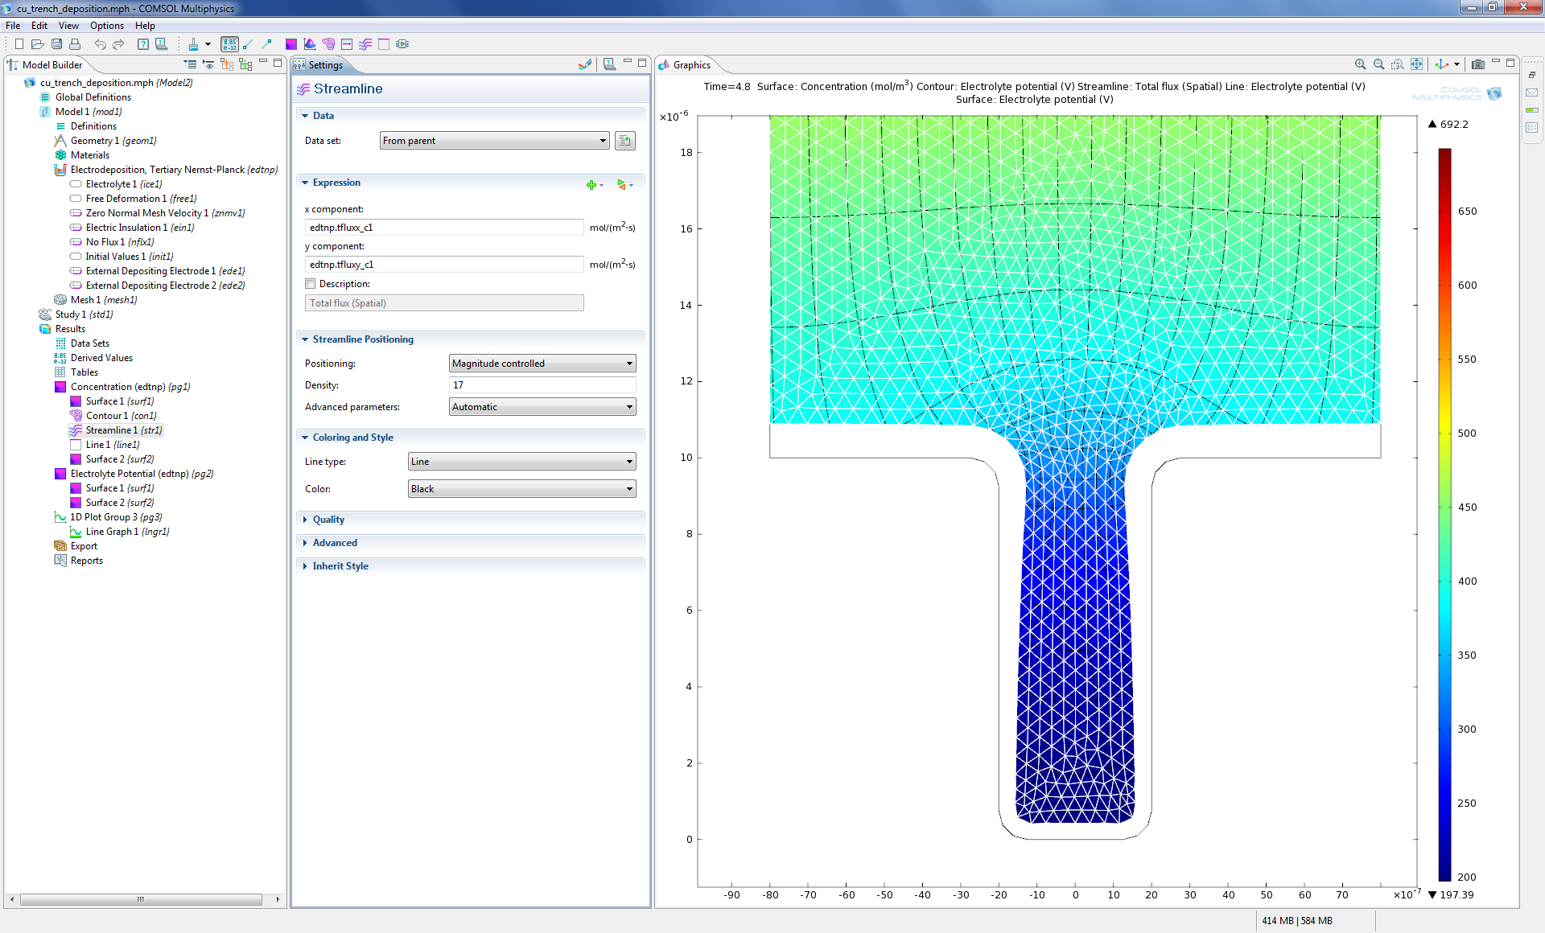
This model of copper deposition in a trench-like geometry illustrates the use of moving meshes in accounting for the relatively large changes in geometry as electrodeposition of copper takes place on a cathode surface. Both electrode kinetics and transport by diffusion and convection of ions are accounted for, and the model is therefore referred to as a tertiary current density distribution model.

“Modeling and simulation are cost effective ways for understanding, optimizing, and controlling electrodeposition processes, so it’s great news for the simulation community that we now offer the Electrodeposition Module for COMSOL’s powerful multiphysics environment,” comments Dr. Ekstrom. “Electrodeposition processes previously beyond reach for simulations are now available in a standard simulation environment with an easy-to-use user interface.”

Electrodeposition Module Highlights

- Work with real CAD geometry models and leading CAD formats.
- Multiple reactions using full electrode kinetic expressions for the charge transfer for estimating the composition of different metals of the deposit and the extent of hydrogen evolution.
- Electroless deposition: Mixed electrode potential and current density calculations at zero net current.
- Shape and composition calculations of electrodeposits using Faraday's law and material balances for the deposited or dissolved metal at the electrode surfaces.
- Moving boundaries with automatic remeshing for large changes in cathode and anode shape.
- Material balances in the electrolyte, including transport by diffusion, migration, convection, and homogenous electrolyte reactions.
- Surface chemistry of adsorbed species.
- Charge balances using electroneutrality or Poisson's equation.
- Current and potential distribution in the electrolyte, at the electrode surfaces, and in the electrodes in the cell.
- Fluid flow and heat transfer coupled to ion transport, electric conduction in the electrode, and electrode charge transfer reactions.

About COMSOL
COMSOL Multiphysics is a software environment for the modeling and simulation of any physics-based system. A particular strength is its ability to account for multiphysics phenomena. Optional modules add discipline-specific tools for mechanical, fluid, electromagnetics, and chemical simulations, as well as CAD interoperability. Founded in 1986, the company has U.S. offices in Burlington, MA, Los Angeles, CA, and Palo Alto, CA. International operations have grown to include offices in the Benelux countries, Denmark, Finland, France, Germany, India, Italy, Norway, Sweden, Switzerland, and the United Kingdom. Independent distributors of COMSOL Multiphysics are located in Australia, China, Egypt, Greece, Hungary, Israel, Japan, Korea, Malaysia, Poland, South Africa, the Czech Republic, Spain, Taiwan, and Turkey. Additional information about the company is available at www.comsol.com.
###
COMSOL and COMSOL Multiphysics are registered trademarks of COMSOL AB. Capture the Concept and COMSOL Desktop are trademarks of COMSOL AB. Other product or brand names are trademarks or registered trademarks of their respective holders.

