COMSOL, Inc.
1 New England Executive Park, Ste 350
Burlington, MA 01803
Tel: 781-273-3322
Fax: 781-293-6603
Web: www.comsol.com
E-Mail: info@comsol.com

Note to editors: Hi-res images of COMSOL Multiphysics are available for download at
http://www.comsol.com/press/gallery.

COMSOL Contact:
Lauren Sansone, Marketing Manager
lauren.sansone@comsol.com

COMSOL Opens New Office in Berlin
New subsidiary offers closer proximity to companies and scientific institutions
in Berlin and the greater Berlin area
Burlington, MA (April 3, 2012) — COMSOL today announced that it opens a new technical sales and support office in the center of Berlin. With this new satellite office, COMSOL further strengthens its presence in Berlin and the greater Berlin area, which is home to some of the world's most prestigious research institutes, including the Fraunhofer, the Leibniz, the Max Planck, and the scientific, technical, and bio-medical research centers of the Helmholtz Association.

“Not only is Berlin the capital of our country, it is well on its way to becoming Germany’s number one scientific and high-tech location,” says Dr. Bernhard Fluche, managing director of Comsol Multiphysics GmbH. “Berlin is one of the leading regions for electro-mobility and the place of business for many international companies researching and developing new products and new technologies in such areas as biotechnology, electronics, automotive systems, pharmaceuticals, and medical equipment. The companies and research institutes in Berlin are exactly those who can achieve enormous breakthroughs with our solutions. I am very much looking forward to the opening of our new Berlin office.”

Many research institutes and companies in Berlin already use COMSOL Multiphysics or are planning to do so, according to Dr. Fluche. “Some ten years ago, multiphysics simulation really took off in Germany," he says. “Today, leading high-tech firms in Germany have adopted COMSOL as their product development environment for such diverse applications as MEMS-based sensors, power grid components, fuel cells, plastics, and more. COMSOL would like to contribute to further strengthening Berlin’s leading position in these technologies, and the new office will ensure a better support of local users.”

“German scientists, engineers, and research institutions are considered world leaders in just about every area of technological research and development,” comments Bernt Nilsson, Senior Vice-President of Marketing of COMSOL, Inc. from his office in Burlington, Massachusetts. “Sales of COMSOL Multiphysics in Germany are growing rapidly. And new and potential users pack our workshops and events throughout Germany to learn more about multiphysics simulation, and the Berlin area in particular is buzzing with activity. Opening a new office in Berlin is a major milestone that will enable a continuous rapid growth of COMSOL Multiphysics in this hub of technology."

Initial plans call for the Berlin office to open with five new technical sales employees with an expansion to 10-15 employees at a later date. Currently, the Berlin office will focus software sales as well as complementing and supporting the activities of the German headquarters in Göttingen. The office will be managed by Dr. Fluche, who will split his time between the Berlin and Göttingen offices.

Berlin Partner assisted Comsol Multiphysics GmbH in the process of choosing a location and is pleased with the company’s decision for a site in Berlin. Berlin Partner has been active in supporting the company with its applications for investment funding. Comsol will furthermore profit from the strong network in the life sciences region Berlin-Brandenburg. Berlin Partner will continue to provide consultations and assist the company in the future, in particular in areas such as the recruitment of specialist employees for the new office in the capital.

The address of the new Berlin office of Comsol Multiphysics GmbH is:
Comsol Multiphysics GmbH
Kurfürstenstr. 84
10787 Berlin

About COMSOL
COMSOL Multiphysics is the leading software environment for the modeling and simulation of any physics-based system. A particular strength is its ability to account for multiphysics phenomena. Optional modules add discipline-specific tools for mechanical, fluid, electromagnetics, and chemical simulations, as well as CAD interoperability. Founded in 1986, the company has U.S. offices in Burlington, MA, Los Angeles, CA, and Palo Alto, CA. International operations have grown to include offices in the Benelux countries, Denmark, Finland, France, Germany, India, Italy, Norway, Sweden, Switzerland, and the United Kingdom. Independent distributors of COMSOL Multiphysics are located in Australia, China, Egypt, Greece, Hungary, Israel, Japan, Korea, Malaysia, Poland, South Africa, the Czech Republic, Spain, Taiwan, and Turkey. Additional information about the company is available at www.comsol.com
###
COMSOL and COMSOL Multiphysics are registered trademarks of COMSOL AB. Other product or brand names are trademarks or registered trademarks of their respective holders.

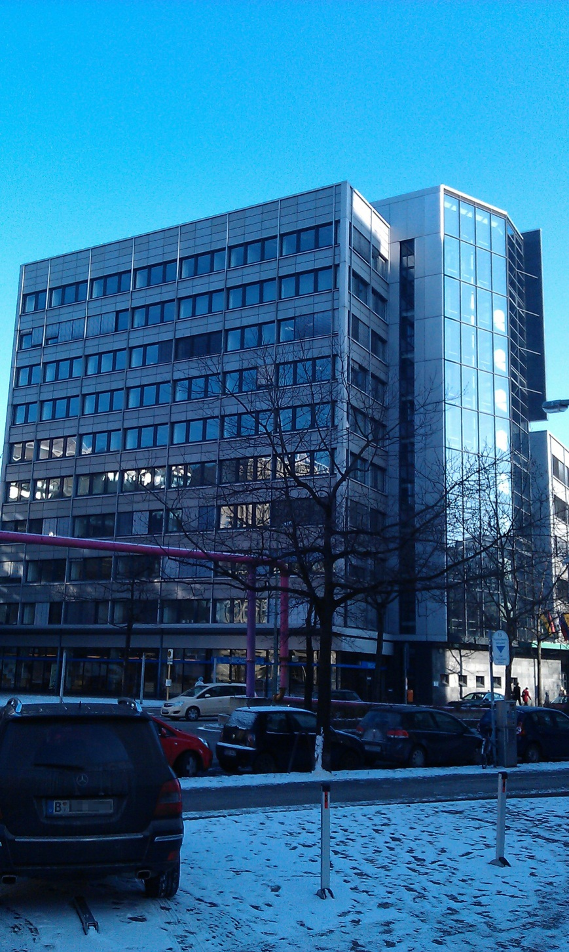
The new satellite office of Comsol Multiphysics GmbH is on the 6th floor of this building located at Kurfürstenstr. 84, Berlin.

