COMSOL, Inc.  1 New England Executive Park, Ste. 350  Burlington, MA. 01803 USA  Phone: +1 781-273-3322  Fax: +1 781-273-6603  Web: www.comsol.com  E-mail: info@comsol.com | Editor contact:  Valerio Marra  Technical Marketing Manager  valerio@comsol.com  Note to editors: Hi-res files for the following images are available for download at www.comsol.com/press/imagegallery.php

COMSOL Multiphysics 4.3a Released

Version 4.3a introduces new LiveLink™ products for Microsoft® Excel® 2010 for Windows® and Solid Edge®, Amazon EC2™ cloud computing support, and ECAD file import. New Fatigue Module expands the mechanical simulation capabilities to calculate high- and low-cycle fatigue. All 30+ extension modules have been upgraded.

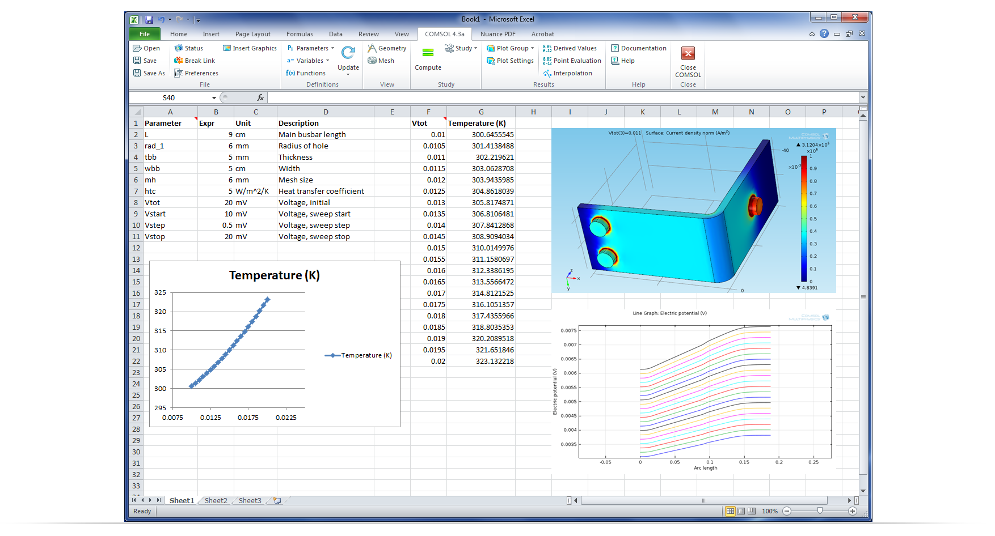
LiveLink™ for Excel® adds a dedicated COMSOL® tab to the Excel 2010 for Windows® ribbon bar, providing easy access to COMSOL’s parameters, variables, functions, geometry, mesh, solvers, and results. Here, LiveLink for Excel was used for a parameterized high-power direct current COMSOL Multiphysics® simulation of a bus bar. The parameters controlling the geometric dimensions as well as the applied voltage were edited in an Excel spreadsheet. Those changes made in Excel were then synchronized to the COMSOL model.
BURLINGTON, MA (October 1, 2012) — Continuing its tradition of innovation that users have come to expect, COMSOL today introduces Version 4.3a of COMSOL Multiphysics®, its flagship software for modeling and simulating physics-based systems. With version 4.3a and in response to user requests, COMSOL introduces LiveLink™ for Excel® to connect multiphysics results with spreadsheets. Version 4.3a also further extends the ability of engineers, scientists, and researchers to leverage multiphysics to design and optimize breakthrough products and technologies anywhere from the desktop to the cloud with new support for cluster computing on the Amazon Elastic Compute Cloud™ (Amazon EC2™). New modules for analyzing fatigue and for importing ECAD files make their debut in Version 4.3a as does the new LiveLink for Solid Edge®, a CAD software from Siemens PLM Software. Additionally, every one of the more than 30 application-specific COMSOL add-on modules for mechanical, electrical, fluid, and chemical modeling and simulation sees major new upgrades. COMSOL Multiphysics 4.3a will be available for download starting October 8.

Multiphysics Simulations and Excel Spreadsheets Linked

Version 4.3a’s new LiveLink product for Microsoft Excel 2010 for Windows enables users to run COMSOL Multiphysics directly within Excel, significantly simplifying the workflow of simulation.

“LiveLink for Excel is a game changer that brings multiphysics to engineers and scientists everywhere,” says Lars Gregersen, Technical Product Manager at COMSOL. “With LiveLink for Excel as well as the new tools and extension modules in Version 4.3a, not only have we expanded the COMSOL simulation platform, we have further strengthened the role of multiphysics simulation in the product design tool chain.”

LiveLink for Excel works by adding a COMSOL tab to the new ribbon toolbar in Excel. From this tab users can control a COMSOL model. Parameters and variables used in the COMSOL Multiphysics model are available for editing in Excel instantly, and any edits to those parameters and variables in Excel can then be synchronized with the COMSOL model with a click of a button.

“Users of LiveLink for Excel will appreciate the new ribbon toolbar in Excel,” says Gregersen. “It’s a whole new user-experience that provides a fresh new way for users to control a multiphysics model. From within Excel you can now access parameters, variables, geometry model, meshes, visualizations, and results.”

LiveLink for Excel also allows users to save and load Excel spreadsheet files of experimental, validation, calibration, and other data related to a simulation from within COMSOL. Additionally, in a separate window, LiveLink for Excel presents simulation results through interactive 3D plots. Users can then insert these plots into an Excel worksheet with just a single mouse-click.

“LiveLink for Excel offers huge benefits for companies just now adding multiphysics-capable simulation tools throughout their design teams,” adds Gregersen. “Through the new LiveLink for Excel connection and our interfaces with major CAD packages, COMSOL fits right into their workflow.”

Users with current COMSOL subscription as of October 1st, 2012, will receive LiveLink for Excel free of charge. LiveLink™ for Excel currently requires Microsoft Excel 2010 for Windows®. Subscription is optional, renewal fees will apply going forward.

Cluster Sweep in the Cloud Boosts Simulation Speed

Adding a completely new dimension to the COMSOL modeling and simulation experience, Version 4.3a extends its support for cloud computing to Amazon’s Elastic Compute Cloud (Amazon EC2). Amazon EC2 delivers a scalable, pay-per-use compute capacity that can save users the expenses associated with purchasing and maintaining high-end workstations or in-house cluster networks, both of which are often underutilized.

Executing a complex multiphysics analysis on Amazon EC2’s high-end hardware is easy too. Users with a floating network license simply upload their COMSOL executable and their model to Amazon EC2. To run their models and simulations, users can leverage cloud computing on Amazon EC2 in three ways: as a virtual machine, as a cluster computing environment for large distributed problems, and as a platform to run massively parallel parametric studies.

Using Amazon EC2 as a single virtual machine means that engineers have access to as much RAM as needed whenever they run large simulations. By employing COMSOL’s cluster computing capabilities with Amazon EC2, users can solve very large distributed models on multiple computer resources (nodes) that might not be available locally as well as save valuable time to solution.

The recently introduced Cluster Sweep feature is engineered for compute-intensive jobs such as parametric studies and frequency sweeps. Cluster Sweep can significantly shorten the time to solution by enabling users to deploy in parallel as many CPUs as needed to solve their problem. Leveraging Cluster Sweep on a compute cluster such as Amazon EC2 lets users run multiple parallel processes with each individual process dedicated to a single parameter set of the same problem.

Fatigue Module Computes Structural Fatigue Life

Although structural analyses can result in a design that’s well within the limits of its materials yield-stress limits, the same design’s structure can fail when subjected to repeated load-cycles. The new Fatigue Module leverages the strength of the Structural Mechanics Module and the versatility of the COMSOL Multiphysics environment to help users determine how many load-cycles a structure can withstand.

The Fatigue Module provides both high-cycle and low-cycle – stress and strain, respectively – fatigue analysis methods. When also combined with the Nonlinear Structural Materials Module, users can perform full elastoplastic fatigue evaluations. Results include visualization of fatigue life based on the number of cycles until failure as well as fatigue usage factor. The Fatigue Module is offered as an add-on to the Structural Mechanics Module.

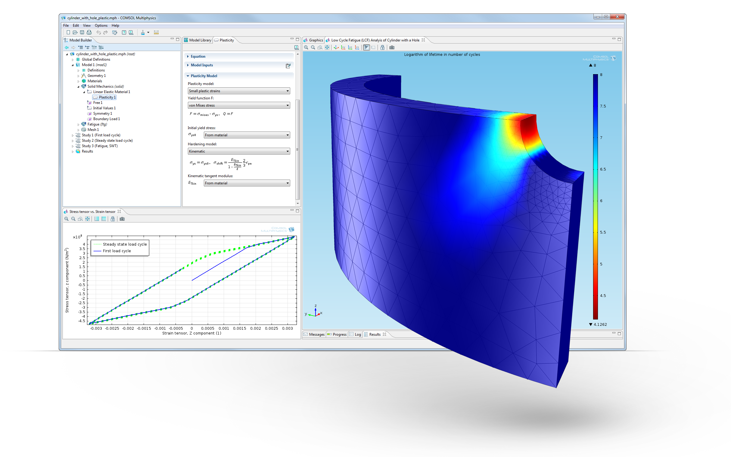
Low-cycle fatigue (LCF) analysis of a component subjected to multi-axial cyclic loading with an elastoplastic material model. Here, different fatigue criteria are in the process of being compared. This solved and fully documented model is available from the COMSOL Model Library.

ECAD Import Module

With the debut of the ECAD Import Module, electrical engineers can now import their electrical CAD files into COMSOL easily, and then simulate the physics of their electronic circuit components and circuit layouts using any COMSOL application-specific module. Among the applications that will benefit by taking advantage of the ECAD Import Module are determining the performance of RF components under thermal or mechanical load and analyses of power electronics devices, solder creep, and PCB vibration.

The ECAD Import Module’s import capabilities include the GDS II, NETEX-G, and ODB++ file formats, and the Module offers the ability to create a 3D geometry model during the import operation automatically. The ECAD Import Module also provides new tools that make it easy to select and import subsets of cells, nets, and layers as well as edit layer thickness, control the geometric representation of bond wires, and specify dielectric regions. Users can store associated layer thickness data for repeated use.

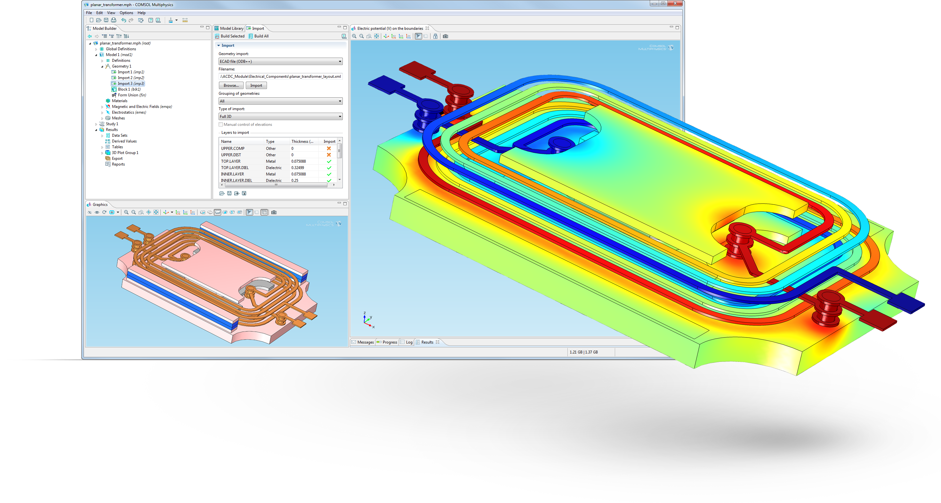
Capacitance and inductance extraction for a planar transformer model imported as an ECAD file. This type of device is used in power supplies and DC/DC converters where a slim high-power design is crucial. The entire layout, including the footprint of the transformer ferrite core, was imported from an ODB++(X) file. The new ECAD Import Module read the layout and automatically created a 3D geometry model of the PCB and the ferrite core in COMSOL Multiphysics. Once the geometry was imported into COMSOL, the user could run any simulation such as thermal and mechanical analysis.

LiveLink for Solid Edge

Joining the family of COMSOL interfacing products, LiveLink for Solid Edge provides an associative, bidirectional link that expands the CAD user’s engineering ability. By establishing an integrated link, any changes to a Solid Edge design feature automatically update the geometry in COMSOL Multiphysics, while retaining model settings. LiveLink for Solid Edge also provides the user with powerful repair and defeaturing tools for preparing the CAD model for simulation.

“Users of Siemens PLM Solid Edge are important members of the CAE community, which COMSOL and its products complement well,” says Phil Kinnane, COMSOL’s VP of Business Development. “Combining COMSOL Multiphysics simulations with Solid Edge designs will increase the understanding of how a process or physical phenomenon operates in the real world, which allows for rapid conceptual design and short time-to-market.”

Parameter Optimization

Version 4.3a of the Optimization Module has been expanded with three new optimization methods – Nelder-Mead, Coordinate Search, and Monte Carlo – that users can apply to any COMSOL Multiphysics model and use with every application-specific module. Users can optimize one or more geometric dimensions for a CAD model created directly with COMSOL Multiphysics or linked through any of the LiveLink products. While optimization control parameters typically are geometric dimensions, they can represent any other parameter used as an input to the analysis such as total power of a heater, material properties, or applied force. The optimization objective function, which can be either minimized or maximized, can be any scalar quantity derived from the simulation results.

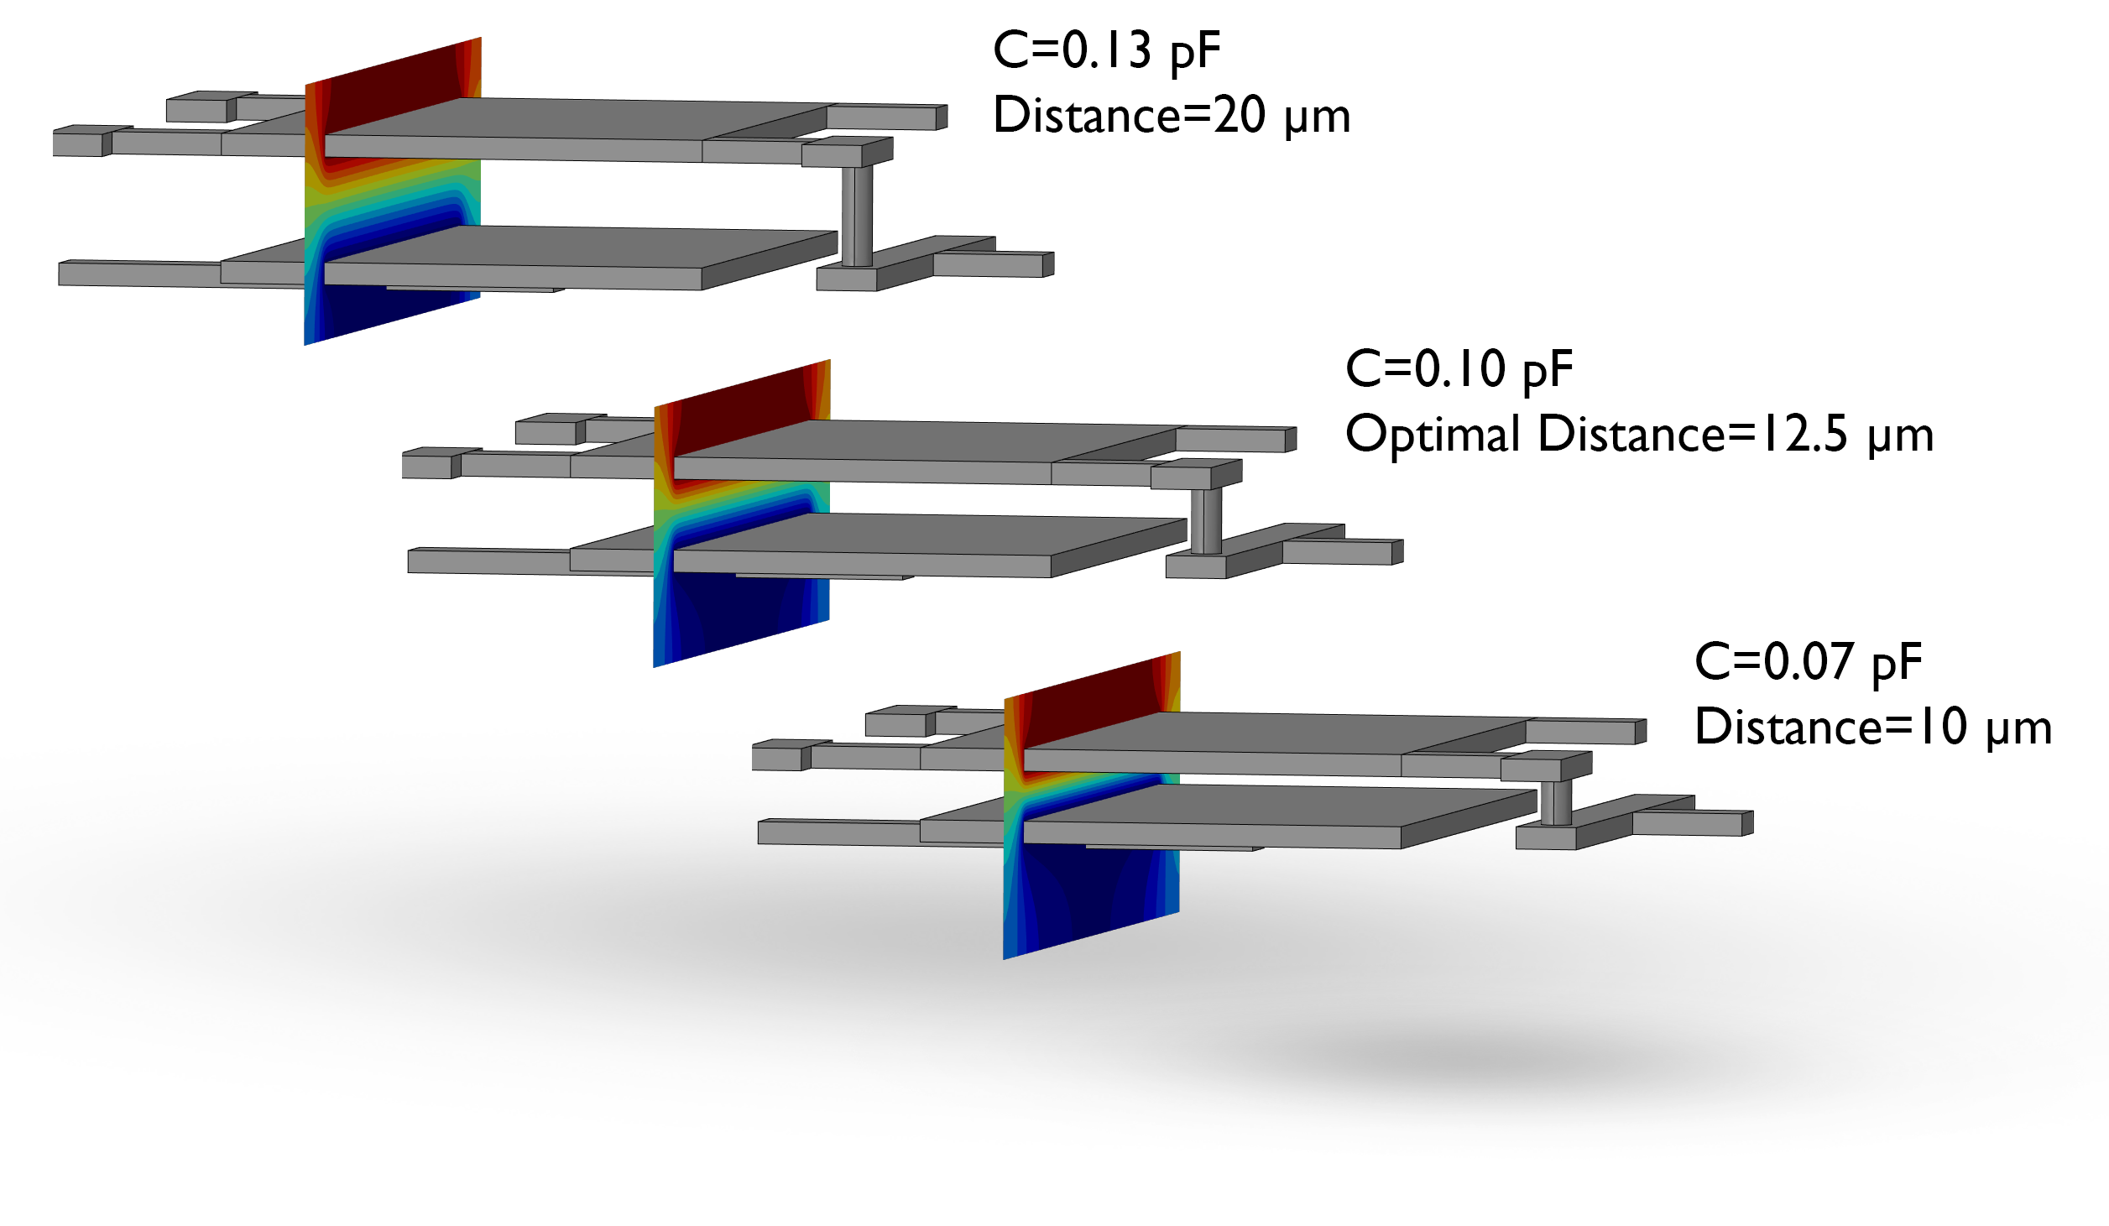
Tunable MEMS capacitors are used in tunable filters and tunable mobile antennas in wireless devices, including multiple-band cell phones. In this model a target capacitance of 0.1 pF was found by optimizing the distance between the capacitor plates. Shown here are three configurations for different offset distances of the lower capacitor plate. An optimal distance of 12.5 µm was computed.

CFD Meshing and Solvers

COMSOL’s CFD (Computational Fluid Dynamics) capabilities see major upgrades in Version 4.3a, including expanded techniques for solving FSI (Fluid-Structure Interaction) problems and several new automatic meshing tools.

For solving FSI applications efficiently, earlier releases of COMSOL offered bidirectional coupling for FSI problems where a strong coupling between fluid and solid existed. Version 4.3a extends COMSOL’s versatility with the introduction of new methodologies for one-way coupled stationary and transient applications in which there is no coupling from the solid back on the fluid.

CFD users will also benefit from new solver features that reduce memory requirements for large models and provide automatic solver tuning. With Version 4.3a COMSOL now automatically adapts the type of solver used to the number of finite elements in a model. Stationary flow and FSI applications now use a pseudo-time stepping method that enables robust convergence towards a steady-state solution.

Several automatic meshing tools for CFD assignments debut in Version 4.3a. For example, the meshing algorithm now finds and refines the mesh at reentrant corners automatically, and creating boundary-layer meshes has been enhanced with new techniques for handling sharp corners. Additionally, boundary layer meshing is tightly integrated with new CFD solver features and now applies to membranes or shells represented as interior boundaries.

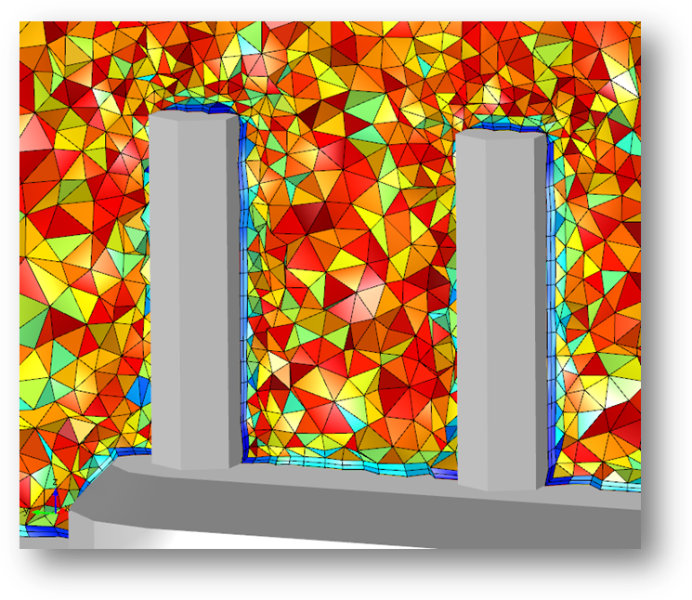
This picture shows the finite element mesh of a heat sink. The automatically applied boundary layer mesh combined with automatic corner refinement and new handling of sharp edges enable robust convergence of the CFD and heat transfer simulation. A selection of the fluid bulk and boundary layer mesh is shown where color represents element quality.

Geometry Selection

In keeping with the COMSOL tradition of constantly improving the user experience, Version 4.3a adds new selection tools that make using the software friendlier. One handy tool allows the user to select a single face and include all adjacent boundaries with continuous tangents. Another is the new cylinder selection, which makes it possible to use a coordinate-based cylinder for selecting objects in a geometry model. Both of these new features not only make boundary selection easier but they reduce the number of required mouse clicks.

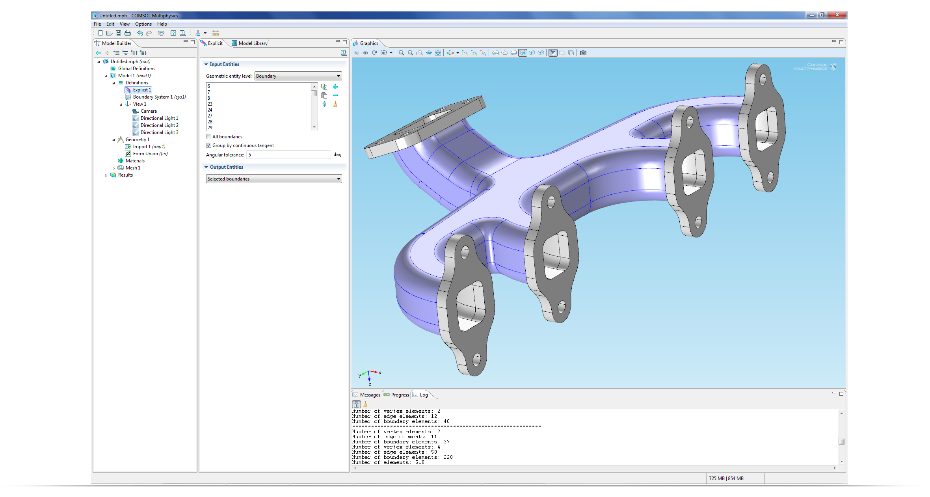
In COMSOL Version 4.3a selecting boundaries in geometry models such as this exhaust manifold is easy with the new continuous tangent selection tool.

Design and Optimization from the Desktop to the Cloud

COMSOL Multiphysics Version 4.3a continues the COMSOL tradition of empowering its users with tools designed to inspire innovation through exceptional usability and the power to deliver highly optimized products quickly. Version 4.3a represents a significant step toward the integration of the simulation, design, and optimization processes for engineers everywhere. By extending interfaces to more design and engineering tools, opening up greater access to cloud computing, delivering new tools to analyze real-world physics problems, and increasing overall performance, COMSOL Multiphysics Version 4.3a promises huge benefits for its users now and well into the future.

Major News in COMSOL Multiphysics Version 4.3a At a Glance

- LiveLink™ for Excel®
  - Run COMSOL simulations from within Microsoft Excel 2010 for Windows®.
  - Load Excel files into COMSOL.
- Fatigue Module
  - Mechanical fatigue based on stress or strain evaluations.
- ECAD Import Module
  - Import of ECAD layouts with new functionality for filtering of cells, nets, and layers.
- LiveLink™ for Solid Edge®
  - Bidirectional associativity with files created with the Solid Edge CAD software from Siemens PLM Software.
- Cloud Computing
  - Support for cloud computing with Amazon Elastic Compute Cloud™ (Amazon EC2™).
- Parameter Optimization
  - Optimize designs based on geometry model dimensions or other parameters.
- More Efficient CFD Solvers
  - Optimized solvers for flow simulations and new methods for solving for fluid structure interactions.
- Accelerated parallel computing.
- For detailed information on COMSOL Multiphysics version 4.3a please visit www.comsol.com/4.3a

About COMSOL

COMSOL Multiphysics is a software environment for the modeling and simulation of any physics-based system. A particular strength is its ability to account for multiphysics phenomena. Optional modules add discipline-specific tools for electrical, mechanical, fluid, and chemical applications. COMSOL Multiphysics and all its modules easily integrate with other parts of the CAD, CAE, and ECAD markets through built-in functionality or add-on products. Founded in 1986, the company has U.S. offices in Burlington, MA, Los Angeles, CA, and Palo Alto, CA. International operations have grown to include offices in the Benelux countries, Denmark, Finland, France, Germany, India, Italy, Norway, Sweden, Switzerland, and the United Kingdom. Independent distributors of COMSOL Multiphysics are located in Australia, China, the Czech Republic, Egypt, Greece, Hungary, Israel, Japan, Malaysia, Poland, South Africa, South Korea, Spain, Taiwan, and Turkey. Additional information about the company is available at www.comsol.com.

###

COMSOL, COMSOL Multiphysics, COMSOL Desktop, and LiveLink are registered trademarks or trademarks of COMSOL AB. Solid Edge is a registered trademark of Siemens Product Lifecycle Management Software Inc. Excel and Windows are registered trademarks of Microsoft Corporation. Amazon EC2 and Amazon Elastic Compute Cloud are trademarks of Amazon Web Services, LLC or its affiliates. Other product or brand names are trademarks or registered trademarks of their respective holders.

