COMSOL, Inc.  1 New England Executive Park, Suite 350  Burlington, MA 01803 USA  Phone: +1 781-273-3322  Web: www.comsol.com | COMSOL Co., Ltd.  Suite 2C, Lujiazui Financial Service Plaza  1217 Dongfang Road, Pudong District  Shanghai, China 200127  Web: www.cn.comsol.com  Media Contact: Xiaoyin He, Marketing Director  Xiaoyin.he@comsol.com
COMSOL Strengthens Global Presence with New Offices in China
COMSOL opens offices in Shanghai and Beijing and publishes all-new Chinese language website to promote the growth and development of multiphysics simulation software in the Chinese market.

STOCKHOLM, SWEDEN (January 13, 2014) – COMSOL is excited to announce COMSOL Co., Ltd. as a new subsidiary located in China with the opening of offices in Shanghai and Beijing. The new offices establish COMSOL direct operations in China by providing software sales, exceptional technical support, comprehensive training sessions, hands-on workshops, user conferences, and customer events. As a part of this opportunity, COMSOL product descriptions have been translated into Chinese for the first time and are available at www.cn.comsol.com/products.

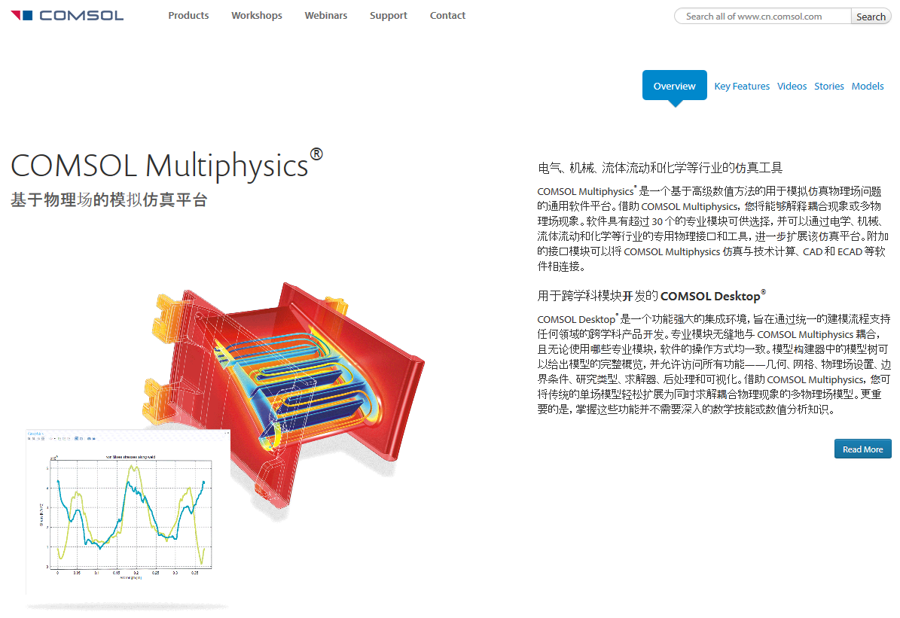
COMSOL product descriptions are now available in Chinese at www.cn.comsol.com/products.
The company’s expansion into the Chinese market comes in response to the rapidly growing demand for COMSOL Multiphysics® simulation software within the country’s diverse high-tech industry and engineering community. “Shanghai and Beijing were chosen as locations for the offices due to their strong science and technology sectors and proximity to a community of talented professionals who have the expertise to best serve our customers,” says Lei Chen, General Manager of COMSOL Co., Ltd. “The Beijing and Shanghai offices start off with a team of application engineers who will provide high-quality customer service for users of COMSOL Multiphysics in China.”

The commitment of COMSOL to recruit and train highly-educated application experts and technical sales representatives within China will be beneficial to the COMSOL user community. "COMSOL Multiphysics is a very sophisticated software, and it will be very helpful to access timely technical support to get the most out of the software," says Dr. Yihe Hua, Senior Engineer at GE Global Research Center, Shanghai. "I believe a highly skilled local team will provide excellent services. We are happy to see that COMSOL is making this large investment in China."

Many events are being planned for the near future where existing COMSOL customers and new users alike will get ample opportunities to connect with colleagues and COMSOL team members. Launch events introducing COMSOL Multiphysics 4.4 -- the latest version of the company’s powerful platform for the modeling and simulation of electrical, mechanical, fluid, and chemical applications -- will be held this spring in Shanghai and Beijing. Following this is a series of free-of-charge workshops where participants get the opportunity to interact with COMSOL applications experts, try out the software under their guidance, and receive a trial to explore its capabilities further. Over a hundred workshops will be held throughout the country where anyone with an interest in multiphysics modeling and simulation is invited. The COMSOL Conference 2014 will be the highlight of the year with major new product releases, training sessions, and user presentations.

Due to the booming engineering market in China and the success of COMSOL Multiphysics, COMSOL is expecting the new offices to encourage tremendous growth of multiphysics simulation in China. “China’s investment in R&D is one of the world’s largest and is expected to keep growing fast for years to come. The country’s focus on innovation and high-tech product development is a perfect match for COMSOL, which provides simulation software that boosts engineering efficiency and productivity,” says Svante Littmarck, CEO and President of the COMSOL Group. “We are delighted to offer local support and sales to existing COMSOL customers while breaking new grounds within this important market.”

About COMSOL
COMSOL provides simulation software for product design and research to technical enterprises, research labs, and universities through over 20 offices and a distributor network all over the world. Its flagship product, COMSOL Multiphysics®, is a software environment for modeling and simulating any physics-based system. A particular strength is its ability to account for coupled or multiphysics phenomena. Add-on products expand the simulation platform for electrical, mechanical, fluid flow, and chemical applications. Interfacing tools enable the integration of COMSOL Multiphysics simulation with all major technical computing and CAD tools on the CAE market.
~
COMSOL, COMSOL Multiphysics, Capture the Concept, COMSOL Desktop, and LiveLink are either registered trademarks or trademarks of COMSOL AB. All other trademarks are the property of their respective owners, and COMSOL AB and its subsidiaries and products are not affiliated with, endorsed by, sponsored by, or supported by those trademark owners. For a list of such trademark owners, see http://www.cn.comsol.com/tm

