COMSOL, Inc.  1 New England Executive Park  Burlington, MA 01803 USA  Phone: +1 781-273-3322  Web: www.comsol.com  Blog: www.comsol.com/blogs | Media Contact:  Natalia Switala, PR & Communications Project Manager  natalia@comsol.com  COMSOL Multiphysics 5.1 release highlights:  www.comsol.com/release/5.1

COMSOL Defines the Standard for Simulation App Design with the Release of COMSOL Multiphysics® Version 5.1

COMSOL Multiphysics® version 5.1 delivers the first integrated software environment that supports the creation of multiphysics models and simulations as well as the building and sharing of easy-to-use simulation apps.

BURLINGTON, MA (April 15, 2015) — COMSOL, the leading provider of multiphysics modeling and simulation software, today announced the release of the COMSOL Multiphysics® software version 5.1, the first and only integrated simulation environment for building multiphysics models and for creating and sharing easy-to-use simulation apps. Simulation experts can now benefit from a fully integrated environment where they can create models with COMSOL Multiphysics, build simulation apps with the Application Builder, and share these apps with non-experts via COMSOL Server™. COMSOL software version 5.1 enhances user experience and productivity by allowing users to seamlessly combine model setup with application design from within a single interface. Major upgrades to the Application Builder include full integration between the Model Builder and Application Builder, improved layout tools for app design, and LiveLink™ for Excel® capabilities in applications. Customers will also benefit from the flexibility of being able to run applications on multiple computers with COMSOL Server.

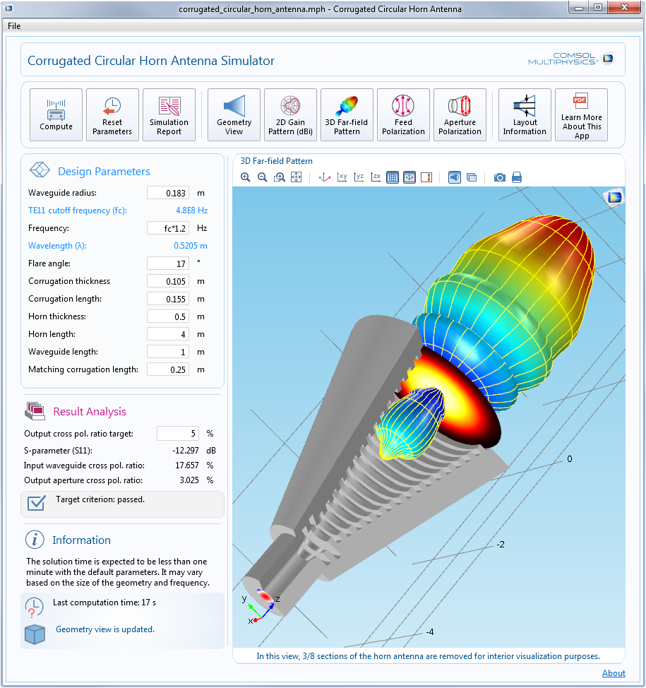
Going from Model to App Is Quick and Easy
In COMSOL Multiphysics 5.1, the Model Builder and Application Builder have been merged into one unified and interactive environment. While building an app, an engineer can easily switch between the Model Builder and Application Builder and make updates to both the model and app simultaneously. The Application Builder is now accessible directly from the ribbon in COMSOL Multiphysics, where the user can simply switch to the app design environment and continue working in just one click. Additionally, both models and apps can be saved in the unified .mph file format.

“The Application Builder is the only application design environment where the user can create multiphysics apps not only within a single software environment, but within a single window using the same file format,” said Bjorn Sjodin, VP of Product Management. “This innovation streamlines the app design process and allows simulation apps to become a truly game-changing engineering solution that will bring powerful design capabilities to non-experts.”
The Corrugated Circular Horn Antenna demo app lets the user modify the geometry of an antenna in order to optimize its radiation characteristics and aperture cross-polarization ratio at the frequency of interest. This app has been created with the Application Builder available in the COMSOL Multiphysics® software.

This streamlined integration of the Model Builder and Application Builder allows model data to be exchanged between the two tools from within the same environment. For example, a function or feature available in the Model Builder can be quickly made available in the Application Builder for the application designer to use. There is no need to interface between different software packages and all tools needed are readily available. Additionally, for instances where the application designer wishes to implement highly-customized commands and operations, code generation is greatly simplified in version 5.1 and many template codes are provided.

“COMSOL today defined the standard for user experience in simulation application design by integrating model building and app design tools into a single environment,” said Svante Littmarck, CEO of COMSOL, Inc. “COMSOL 5.1 delivers additional features that provide our customers with highly productive tools to build and share their simulation applications with users everywhere.”

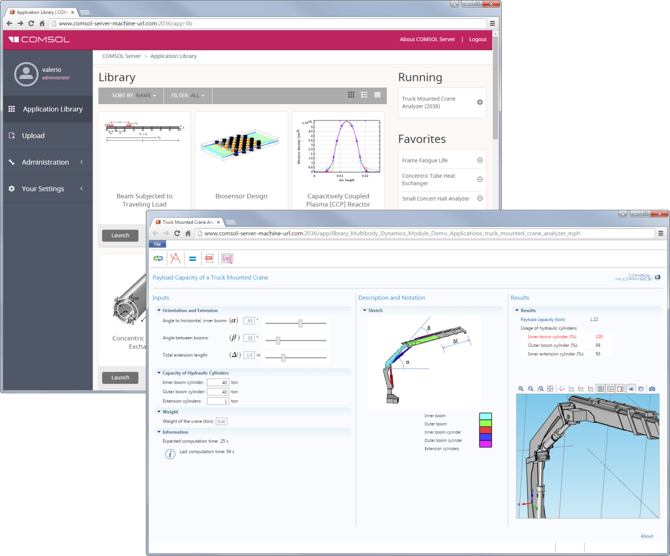
In the demo application Payload Capacity of a Truck Mounted Crane, a rigid-body analysis of a crane is performed in order to find the payload capacity for the specified orientation and extension of the crane. The application also provides the usage of hydraulic cylinders and highlights the limiting cylinder. This app has been created with the Application Builder available in the COMSOL Multiphysics® software and has been shared and launched from COMSOL Server™.
COMSOL Server also includes many improvements. It can now be run on multiple computers, allowing computations to be run on a separate machine from where the app is being launched. The updated Application Library in COMSOL Server features new grid, detail, and list views with information on which add-on products are needed to create a particular application.

To explore the new features, many new demo applications have been added to the Application Libraries and are available within the COMSOL software. “The demo applications include self-contained documentation and showcase many useful features,” said Littmarck. “You can run these applications to explore how to email simulation reports, create animations, perform optimizations and parameter estimation, as well as import experimental data and handle tables. All the demo apps are available for you to edit, and forms, form objects, and methods can be copied from these apps and used as a starting point for your own application designs.”

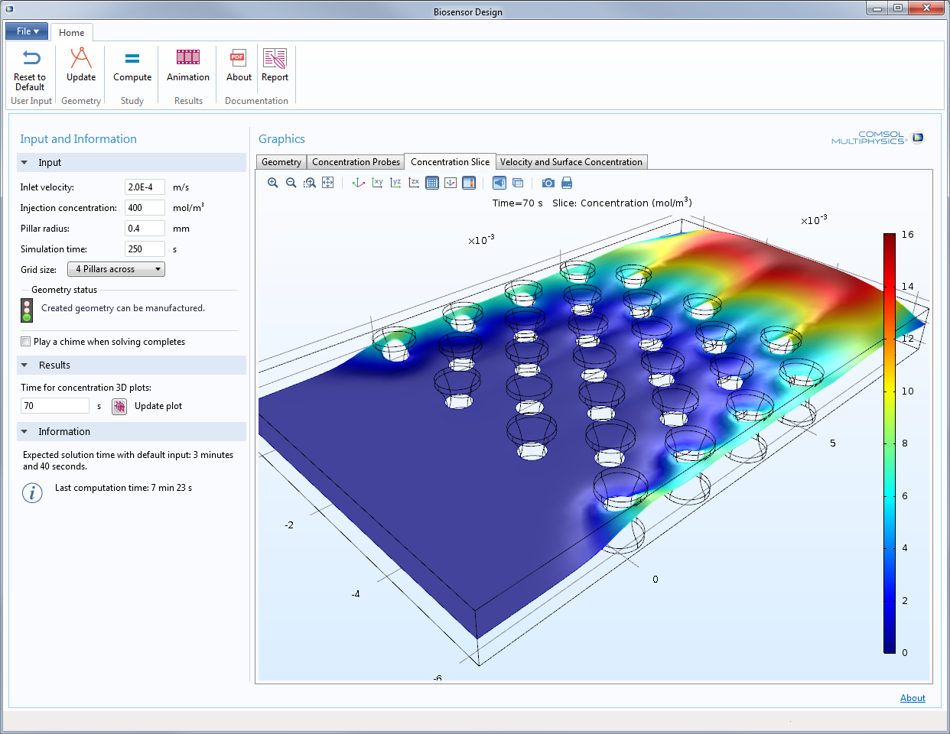
In the Biosensor Design demo application, the user can change the design of the sensor by altering parameters such as pillar diameter, grid spacing, and inlet velocity to investigate how the design affects the detection results. Manufacturing constraints, set by a minimum distance between pillars, are reported in the application.
Hundreds of COMSOL Multiphysics® and Add-On Product Updates Available to Customers
COMSOL Multiphysics users can now browse models and applications without the add-on product licenses and can perform additional postprocessing on the available results. This update will have a major impact on productivity as users can now inspect any COMSOL file and, while the simulation cannot be solved again, can see which features have been used and easily work on models and applications created by others.

Version 5.1 also introduces numerous enhancements to the existing functionalities of COMSOL Multiphysics and its add-on products. Ready-to-use parametric geometry components are now available to use with any module, and a library of dedicated parts has been created for the Microfluidics Module, Mixer Module, Ray Optics Module, and Structural Mechanics Module. The Ray Optics Module and Wave Optics Module will also benefit from the addition of a new Optical Materials Database.

To watch the release highlights video and download COMSOL Multiphysics version 5.1 now, visit www.comsol.com/release/5.1

Highlights of New Features and Tools Available in COMSOL® Version 5.1
- Application Builder and COMSOL Server™: Tighter integration between the Model Builder and Application Builder. Numerous productivity enhancements such as improved file handling, sending emails with attachments, string and keyword searches, custom toolbars for tables, and more. COMSOL Server can now distribute the workload of running applications on multiple computers. 20 fully-documented and ready-to-use simulation apps based on COMSOL models have been added to the Application Libraries.
- Geometry and Mesh: Face detection for imported meshes, surface simplification in mesh to geometry conversion, and domain and boundary selections for NASTRAN® Property ID Numbers tools.
- Modeling Tools, Studies, and Visualization: A new matrix-free domain-decomposition solver. Visualization of a solution outside of the mesh (useful for far fields in electromagnetic waves and acoustic waves). Visualization of a periodic solution in a unit cell as a custom-sized array. Plots of geometric points or cut-points and their trajectory through time.
- Electrical: Multi-turn coil computation for coils with varying cross-sections. Surface roughness on lossy conductive boundaries for electromagnetic wave simulations. Hexagonal periodic structure handling. Special tools for handling ring resonators with the beam envelope formulation. New Optical Materials database. New Part Library for Ray Optics Module. Perforations feature for thin film damping (useful for MEMS). Demo application for computing and visualizing the color of an LED based on semiconductor physics.
- Mechanical: A new multiphysics interface for hygroscopic swelling has been added to the Structural Mechanics Module. Membranes can now have nonlinear materials. Trusses can be modeled to include nonlinear springs and plasticity. A Part Library has also been added for structural applications, which includes beams and bolts. A new Algebraic Turbulence model has been added to the Heat Transfer Module. A new multiphysics interface for heat transfer in porous media enables local thermal non-equilibrium simulations (useful for microwave heating, exothermic reactions, nuclear engineering, electronics system design, and full cells). New predefined impedance boundary conditions for acoustics. Ray acoustics for graded media and fluid models with attenuation.
- Fluid: Euler-Euler two-phase flow with turbulence. Fluid flow simulations can now combine porous media flow with turbulent flow, and porous domains are allowed to be unbounded with the aid of infinite elements. New pressure loss options for T-junctions, Y-junctions, and n-way junctions available for pipe flow simulations. New Part Library available in the Mixer Module.
- Chemical: Macroscale to microscale concentration coupling at pellet-fluid interface. Automatic computation of gas mixture viscosity for fluids and dusty gas model features. A new state-of-the-art multiscale tutorial model of a 3D packed bed reactor with two levels of homogenization.
- Multipurpose: New multiphysics interfaces for particle field interactions and fluid-particle interactions, inelastic collisions, and release of particles using data from an imported text file.
About COMSOL
COMSOL provides simulation software for product design and research to technical enterprises, research labs, and universities through 22 offices and a distributor network throughout the world. Its flagship products, COMSOL Multiphysics® and COMSOL Server™, are software environments for modeling and simulating any physics-based system and for building and distributing applications. A particular strength is its ability to account for coupled or multiphysics phenomena. Add-on products expand the simulation platform for electrical, mechanical, fluid flow, and chemical applications. Interfacing tools enable the integration of COMSOL Multiphysics® simulation with all major technical computing and CAD tools on the CAE market.
~
COMSOL, COMSOL Server, COMSOL Multiphysics, and LiveLink are either registered trademarks or trademarks of COMSOL AB. Other product or brand names are trademarks or registered trademarks of their respective holders.

