COMSOL, Inc.  1 New England Executive Park  Burlington, MA 01803 USA  Phone: +1 781-273-3322  Web: www.comsol.com | Media Contact:  Natalia Switala, PR & Communications Project Manager  natalia@comsol.com  Register for the COMSOL Conference 2015:  www.comsol.com/conference2015
COMSOL Conference 2015 — Call for Papers
Engineers and scientists interested in submitting paper and poster abstracts may visit www.comsol.com/conference2015/call-for-papers for more information.
Boston: Oct 7-9 | Grenoble: Oct 14-16 | Pune: Oct 29-30 | Beijing: Nov 4-5
Curitiba: Nov 5-6 | Taipei: Nov 13 | Seoul: Nov 27 | Tokyo: Dec 3-4 | Kuala Lumpur

BURLINGTON, MA (May 11, 2015) – The program committee of the 11th annual COMSOL Conference today invites engineers and researchers to submit paper and poster abstracts to be considered for presentation at the world’s largest conference on multiphysics simulation. The COMSOL Conference brings together more than 2,000 engineers, researchers, and scientists worldwide, providing them with the chance to showcase their work, share innovative technologies and best practices, as well as the opportunity to interact with the makers of COMSOL Multiphysics®. Presenting a poster, paper, or both at the COMSOL Conference is a unique opportunity for COMSOL Multiphysics users to achieve widespread recognition within a skilled community of engineers.

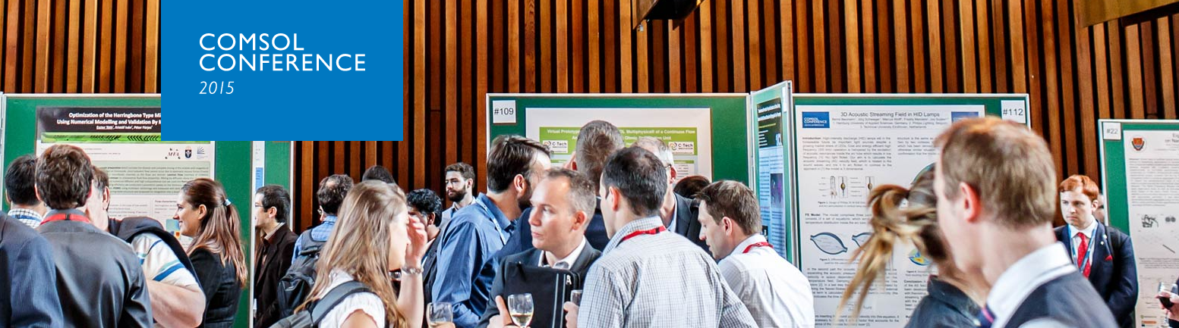

Present Your Work at the COMSOL Conference
Papers, presentations, and posters from the COMSOL Conference are shared with more than 165,000 engineers worldwide, providing researchers with the opportunity to showcase their work with the global engineering community. The conference focuses on advancing cross-discipline and multiphysics simulation by providing conference attendees with a multitude of hands-on sessions, networking opportunities, keynote talks from industry leaders, and over 700 user presentations. Abstracts are reviewed by a Program Committee of highly respected industry professionals, which this year includes members from Boeing, Schlumberger, GE Global Research, Medtronic, and others. “Being a member of the program committee offers a unique opportunity to work with COMSOL and to see how other researchers are using multiphysics simulation in their work,” says John Lutian, a Researcher in Microsoft’s Applied Sciences group. “I’m particularly looking forward to seeing the latest applications of the Wave Optics Module at the COMSOL Conference 2015.”

"The COMSOL Conference is a great opportunity to advance your modeling skills by attending application-specific minicourses taught by COMSOL experts," says Walter Frei, Applications Team Leader. "Minicourses are now offered as lectures and supplemented by hands-on sessions. This provides the ideal place for asking any questions you might have. Additionally, you can attend any combination of the 30 courses offered that you would like."

Conference highlights include:
- Over 30 application-specific minicourses taught by COMSOL specialists covering a wide array of disciplines
- Keynote talks from industry leaders and prominent researchers
- User-contributed paper and poster presentations
- The introduction of the newest simulation tools and technologies
- An exhibition showcasing products offered by COMSOL Partners
- The chance to interact with peers and explore the simulation work of fellow engineers
“One of the most exciting things about this year’s COMSOL Conference is that we will be seeing the simulation apps of COMSOL customers presented for the first time,” says Jennifer Segui, Program Chair for the Boston conference. “We are looking forward to learning more about the innovative ways that our customers have benefited from the Application Builder and COMSOL Server™.”

The deadline to submit an abstract for the COMSOL Conference Boston is July 31, 2015. Instructions for those interested in presenting are available by visiting: www.comsol.com/conference2015/call-for-papers.

Suggested topic areas for papers and posters include, but are not limited to:
- AC/DC Electromagnetics  - Acoustics and Vibrations  - Batteries, Fuel Cells, and Electrochemical Processes  - Bioscience and Bioengineering  - Chemical Reaction Engineering  - Computational Fluid Dynamics  - Electromagnetic Heating  - Geophysics and Geomechanics  - Heat Transfer and Phase Change  - MEMS and Nanotechnology | - Microfluidics  - Multiphysics  - Optics, Photonics, and Semiconductors  - Optimization and Inverse Methods  - Particle Tracing  - Piezoelectric Devices  - Plasma Physics  - RF and Microwave Engineering  - Simulation Methods and Teaching  - Structural Mechanics and Thermal Stresses  - Transport Phenomena
Papers and posters presented at the conference will be published on the COMSOL website where they reach a worldwide audience of engineers. Explore the contributions to last year’s conference at:
www.comsol.com/2014-user-presentations.

For more details about the COMSOL Conference 2015 Boston and to register to attend, visit: www.comsol.com/conference2015/boston.

About COMSOL
COMSOL provides simulation software for product design and research to technical enterprises, research labs, and universities through 22 offices and a distributor network throughout the world. Its flagship product, COMSOL Multiphysics®, is a software environment for modeling and simulating any physics-based system and for building applications. A particular strength is its ability to account for coupled or multiphysics phenomena. Add-on products expand the simulation platform for electrical, mechanical, fluid flow, and chemical applications. Interfacing tools enable the integration of COMSOL Multiphysics® simulation with all major technical computing and CAD tools on the CAE market.
~
COMSOL and COMSOL Multiphysics are registered trademarks of COMSOL AB.

