COMSOL, Inc.  100 District Avenue  Burlington, MA 01803 USA  Phone: +1 781-273-3322  Web: www.comsol.com  Blog: www.comsol.com/blogs | Media Contact:  Natalia Switala, PR & Communications Project Manager  natalia@comsol.com  Register for the COMSOL Conference 2016:  www.comsol.com/conference
COMSOL Conference 2016 — Final Call for Papers
Engineers and scientists interested in submitting paper and poster abstracts may visit www.comsol.com/conference/call-for-papers for more information.
Boston: Oct 5-7 | Munich: Oct 12-14 | Bangalore: Oct 20-21 |
Shanghai: Nov 3-4 | Taipei: Nov 11 | Seoul: Nov 25 | Tokyo: Dec 9

BURLINGTON, MA (June 24, 2015) – The COMSOL Conference 2016 Boston will be held October 5-7, 2016 at the Boston Marriott Newton hotel. The program committee of the 12th annual COMSOL Conference today invites engineers and researchers to submit paper and poster abstracts on numerical simulation and custom applications.

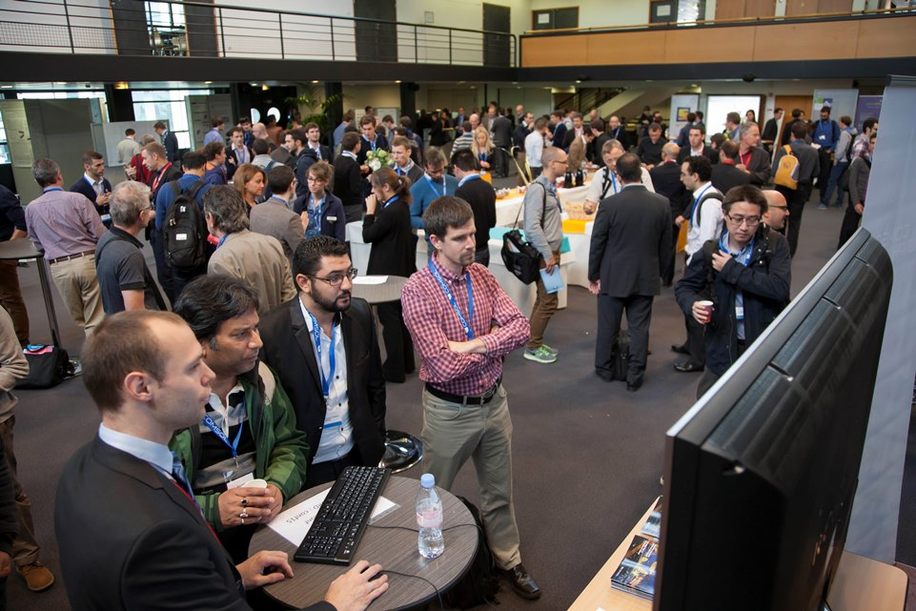

Present Your Work at the COMSOL Conference
Papers, presentations, and posters from the COMSOL Conference are shared with engineers and scientists worldwide, providing presenters with the opportunity to showcase their work with simulation specialists throughout industry and academia. The COMSOL Conference also gives attendees the opportunity to interact with other members of the COMSOL community. Simulation specialists working with similar types of applications discuss and share ideas on how to enhance R&D and product development processes using numerical simulation software.

Abstracts are reviewed by a Program Committee of industry professionals, which this year includes members from NASA Marshall Space Flight Center, St. Jude Medical, Schlumberger, Duracell, and others. “Being a member of the program committee offers a unique opportunity to work with COMSOL and to see how other researchers are using multiphysics simulation in their work," says Yuehao Li, Modeling and Simulation Engineer, Corning. "I’m particularly looking forward to learning more from other COMSOL users who are working at the forefront of product development and research, in reviewing the abstracts and connecting in person."

The deadline to submit an abstract for the COMSOL Conference Boston is July 1, 2016. Instructions for those interested in presenting are available by visiting: www.comsol.com/conference/call-for-papers

Suggested topic areas for papers and posters include, but are not limited to:
- AC/DC Electromagnetics  - Acoustics and Vibrations  - Batteries, Fuel Cells, and Electrochemical Processes  - Bioscience and Bioengineering  - Chemical Reaction Engineering  - Computational Fluid Dynamics  - Electromagnetic Heating  - Geophysics and Geomechanics  - Heat Transfer and Phase Change  - MEMS and Nanotechnology | - Microfluidics  - Multiphysics  - Optics, Photonics, and Semiconductors  - Optimization and Inverse Methods  - Particle Tracing  - Piezoelectric Devices  - Plasma Physics  - RF and Microwave Engineering  - Simulation Methods and Teaching  - Structural Mechanics and Thermal Stresses  - Transport Phenomena

Papers and posters presented at the conference will be published on the COMSOL website. Explore the contributions to last year’s conference at: www.comsol.com/2015-user-presentations

For more details about the COMSOL Conference 2016 Boston, visit: www.comsol.com/conference2016/boston

About COMSOL
COMSOL is a global provider of simulation software for product design and research to technical enterprises, research labs, and universities. Its COMSOL Multiphysics® product is an integrated software environment for creating physics-based models and simulation apps. A particular strength is its ability to account for coupled or multiphysics phenomena. Add-on products expand the simulation platform for electrical, mechanical, fluid flow, and chemical applications. Interfacing tools enable the integration of COMSOL Multiphysics® simulations with all major technical computing and CAD tools on the CAE market. Simulation experts rely on the COMSOL Server™ product to deploy apps to their design teams, manufacturing departments, test laboratories, and customers throughout the world. Founded in 1986, COMSOL employs more than 400 people in 22 offices worldwide and extends its reach with a network of distributors.
~
COMSOL, COMSOL Multiphysics, Capture the Concept, and COMSOL Desktop are registered trademarks of COMSOL AB. COMSOL Server, LiveLink, and Simulation for Everyone are trademarks of COMSOL AB. Other product or brand names are trademarks or registered trademarks of their respective holders.

