COMSOL, Inc.  100 District Avenue  Burlington, MA 01803 USA  Phone: +1 781-273-3322  Web: www.comsol.com  Blog: www.comsol.com/blogs | Media Contact:  Natalia Switala, PR & Communications Project Manager  natalia@comsol.com  Register for the COMSOL Conference 2016:  www.comsol.com/conference
Keynotes Announced for
COMSOL Conference 2016 Boston on Multiphysics Simulation

Boston: Oct 5-7 | Munich: Oct 12-14 | Bangalore: Oct 20-21
Shanghai: Nov 3-4 | Taipei: Nov 11 | Seoul: Nov 25 | Tokyo: Dec 9

BURLINGTON, MA (September 14, 2016) –the organizers of COMSOL Conference 2016 Boston are proud to announce this year’s keynote speakers. The COMSOL Conference is held worldwide in seven major cities. It attracts thousands of engineers and scientists with its focus on multiphysics simulation and application design. The first event is taking place in Boston on October 5-7 and features the following line up of distinguished modeling and simulation professionals:
- Bernard McGarvey, senior engineering advisor at Eli Lilly and Company
- Edward P. Furlani, professor in the Departments of Chemical and Biological Engineering and Electrical Engineering at University at Buffalo (UB) SUNY
- Carl Meinhart, professor of mechanical engineering at the University of California – Santa Barbara (UCSB) and founder and CEO of Numerical Design, Inc.
- Sebastien Perrier, R&D acoustical engineer at Echologics Engineering

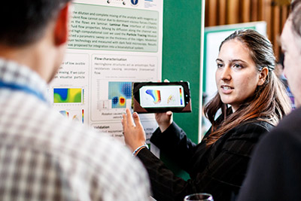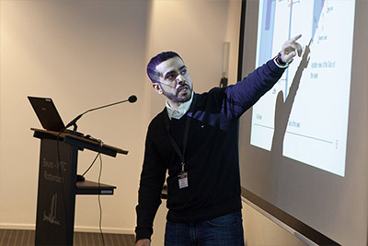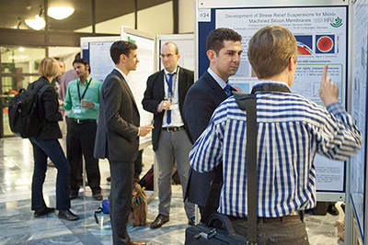

KEYNOTE: Leveraging Modeling and First Principles Thinking to Accelerate Improvement at a Pharmaceutical Company
Dr. Bernard McGarvey is a senior engineering advisor responsible for process modeling applications at Eli Lilly and Company. He supports the application of process modeling in both manufacturing and process development. He has 32 years of experience in manufacturing, where he has held positions in process engineering, process control engineering, and technical services. His interests include general mathematical modeling and simulation, process data analysis, capacity/workflow modeling, risk management, fluid dynamics, cold chain container design and qualification, nonlinear model estimation, and quality engineering. He has a BEng degree and a PhD from University College Dublin, Ireland.

KEYNOTE: Multiphysics and Multiscale Simulations: Advancing Basic Science and Industrial Applications
Dr. Edward P. Furlani holds a PhD in theoretical physics and has a joint appointment as a professor in the Departments of Chemical and Biological Engineering and Electrical Engineering at University at Buffalo (UB) SUNY. He transitioned to academia in 2011 from the Eastman Kodak Research Labs, where he performed interdisciplinary modeling for the development of commercial materials and devices. His industrial experience spans applications in the fields of microfluidics, photonics, applied magnetics, and microsystems technology. His current research involves the development of computational models to design innovative nano- and microstructured materials and devices with unique functionality. His current research spans the applications of microfluidics, biosensing, energy storage, nanophotonics, and magnetic particles. Professor Furlani’s research contributions include over 100 peer-reviewed publications, a textbook on applied magnetics, and numerous invited conference presentations. He also has a distinguished record of translational research and currently holds 152 U.S. patents.

KEYNOTE: Transport Processes in Microfluidics
Dr. Carl Meinhart is a professor of mechanical engineering at the University of California – Santa Barbara (UCSB). He obtained his PhD from the University of Illinois in 1994. Since coming to UCSB in 1996, his research has focused on developing microfluidic devices and investigating their fundamental transport mechanisms. Professor Meinhart’s research on microfluidics has been cited approximately 7,800 times, with an h-index of 34 (Google Scholar™ scholarly texts search). He has seven issued patents. In addition to being a professor at UCSB, Dr. Meinhart is the founder and CEO of Numerical Design, Inc., which is a COMSOL Certified Consultant. Dr. Meinhart is a fellow of the American Physical Society.

KEYNOTE: The Effect of Local Resonators on Sound Propagation in Fluid-Filled Pipes
Sebastien Perrier is a mechanical engineer who received his PhD from the University of Sherbrooke. He specialized in acoustics and vibrations, coupling of structures, and signal processing.
Sebastien has been working with Echologics Engineering for 2 years, applying his expertise to optimize and develop next-generation solutions for buried pipe infrastructure management and leak detection. His work focuses on carrying out laboratory and field tests, developing processes and methods for measuring vibration and pressure events, and pipe modeling.
2016 COMSOL Conference
The COMSOL Conference brings together engineers, researchers, and scientists worldwide throughout seven locations, providing them with the chance to showcase their work, share innovative technologies and best practices, as well as the opportunity to interact with the members of the COMSOL community.

The 2016 conference will feature presentations on simulation apps using the Application Builder and the COMSOL Server™ product. Other highlights include:
- Over 30 hands-on training opportunities to learn how to use COMSOL Multiphysics® software for better R&D and design
- Talks by industry experts on the latest in computational modeling
- Discussion-oriented Focus Sessions covering simulation best practices, moderated by our product managers
- The introduction of the newest simulation tools and technologies
- User-contributed paper and poster presentations
- An exhibition showcasing products offered by COMSOL Certified Consultants, software and hardware providers, and other exhibitors within the CAE industry
- The chance to interact with peers and explore the simulation work of fellow engineers

For more details about the COMSOL Conference 2016 Boston, visit:
www.comsol.com/conference2016/boston

About COMSOL
COMSOL is a global provider of simulation software for product design and research to technical enterprises, research labs, and universities. Its COMSOL Multiphysics® product is an integrated software environment for creating physics-based models and simulation apps. A particular strength is its ability to account for coupled or multiphysics phenomena. Add-on products expand the simulation platform for electrical, mechanical, fluid flow, and chemical applications. Interfacing tools enable the integration of COMSOL Multiphysics® simulations with all major technical computing and CAD tools on the CAE market. Simulation experts rely on the COMSOL Server™ product to deploy apps to their design teams, manufacturing departments, test laboratories, and customers throughout the world. Founded in 1986, COMSOL employs more than 460 people in 22 offices worldwide and extends its reach with a network of distributors.
~
COMSOL, COMSOL Multiphysics, Capture the Concept, and COMSOL Desktop are registered trademarks of COMSOL AB. COMSOL Server, LiveLink, and Simulation for Everyone are trademarks of COMSOL AB. Google Scholar is a trademark of Google Inc. Other product or brand names are trademarks or registered trademarks of their respective holders.

