COMSOL, Inc.  100 District Avenue  Burlington, MA 01803 USA  Phone: +1 781-273-3322  Web: www.comsol.com  Blog: www.comsol.com/blogs | Media Contact:  Natalia Switala, PR & Communications Project Manager  natalia@comsol.com  Multiphysics Simulation 2016 is available at:  www.comsol.com/offers/mphsim16

Leveraging the Power of Multiphysics Modeling and Application
Design and Deployment in Multiphysics Simulation 2016

BURLINGTON, MA (October 25, 2016) — COMSOL, Inc. the leading provider of multiphysics modeling, simulation, and application design and deployment software, is excited to announce that the latest edition of Multiphysics Simulation is now available and may be downloaded at: https://www.comsol.com/offers/mphsim16. The 2016 edition features articles on a range of topics, including 5G simulation apps, implantable medical devices, organic LEDs, and high efficiency photonic switches.

“Multiphysics simulation tools are being used across many industries with great success,” comments Bernt Nilsson, Senior VP of Marketing with COMSOL, Inc. “The Multiphysics Simulation magazine is a compilation of a dozen outstanding product and research projects. In every case, numerical simulation has a major impact on the outcome for organizations that are now expanding the use of simulation to much larger groups of users.”

This edition of Multiphysics Simulation shares a number of stories about how simulation experts are communicating their simulation work with colleagues and customers. A few highlights:
- Researchers at GrafTech developed a detailed model of graphite heat spreaders and turned it into a simulation app for their sales team.
- Within Konica Minolta researchers are using multiphysics simulation to increase light output and energy efficiency in organic LED (OLED) systems.
- The team at Huawei is hard at work designing energy efficient photonic switches to support growing network traffic.

Other articles highlight how industry leaders have employed simulation driven product development practices to stay ahead of the competition. Researchers at St. Jude Medical are using multiphysics simulation to enhance the performance and safety of wireless implantable devices for heart disease patients. The team at ArcelorMittal is perfecting the process for laser welding within the automotive industry.

Multiphysics Simulation 2016 is available as an online magazine and can be viewed digitally or downloaded in PDF format at: https://www.comsol.com/offers/mphsim16.

About COMSOL
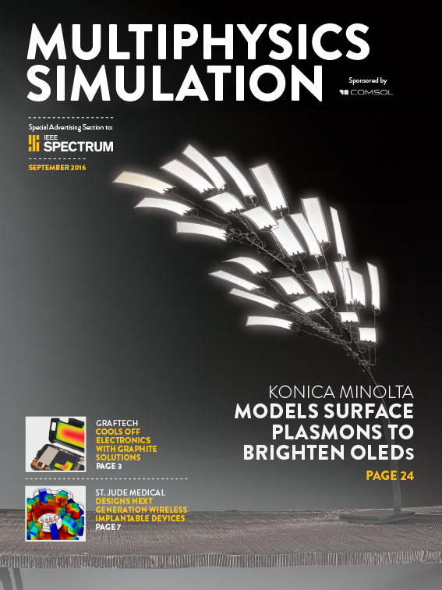
COMSOL is a global provider of simulation software for product design and research to technical enterprises, research labs, and universities. Its COMSOL Multiphysics® product is an integrated software environment for creating physics-based models and simulation apps. A particular strength is its ability to account for coupled or multiphysics phenomena. Add-on products expand the simulation platform for electrical, mechanical, fluid flow, and chemical applications. Interfacing tools enable the integration of COMSOL Multiphysics® simulations with all major technical computing and CAD tools on the CAE market. Simulation experts rely on the COMSOL Server™ product to deploy apps to their design teams, manufacturing departments, test laboratories, and customers throughout the world. Founded in 1986, COMSOL employs more than 480 people in 21 offices worldwide and extends its reach with a network of distributors.
~
COMSOL, COMSOL Multiphysics, Capture the Concept, and COMSOL Desktop are registered trademarks of COMSOL AB. COMSOL Server, LiveLink, and Simulation for Everyone are trademarks of COMSOL AB. Other product or brand names are trademarks or registered trademarks of their respective holders.

