COMSOL, Inc.  100 District Avenue  Burlington, MA 01803 USA  Phone: +1 781-273-3322  Web: www.comsol.com  Blog: www.comsol.com/blogs | Media Contact:  Natalia Switala, PR & Communications Project Manager  natalia@comsol.com  Browse the COMSOL Conference 2016 User Presentations at:  www.comsol.com/2016-user-presentations

Best Paper and Poster Award Winners Announced from Around the Globe at the COMSOL Conference 2016
COMSOL Conference 2016 User Presentations Now Available

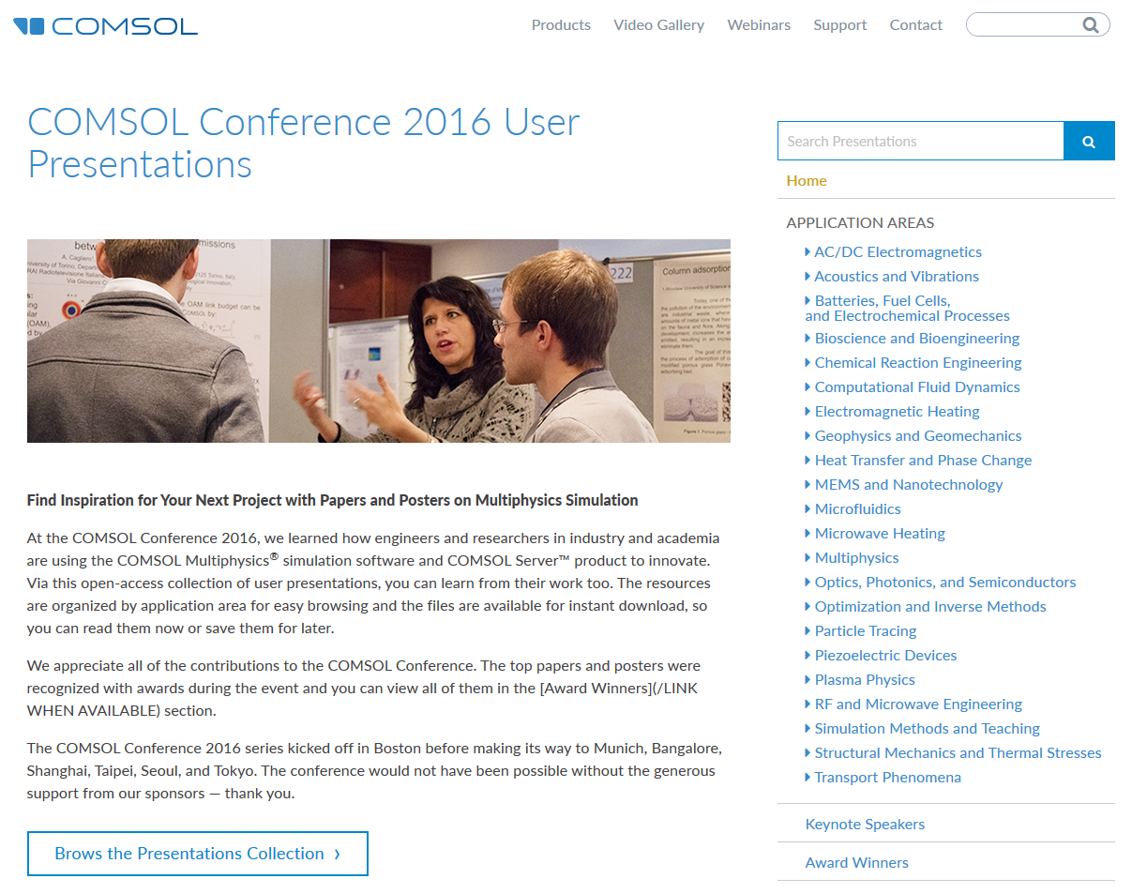
BURLINGTON, MA (November 30, 2016) — COMSOL Conference 2016, brought together thousands of simulation experts around the world to share their modeling and simulation work. Users of the COMSOL Multiphysics® software and COMSOL Server™ product contributed with hundreds of papers, posters, presentations, and keynotes highlighting engineering, research, and simulation apps. The user presentations are available in an open-access resource that covers the latest in a diverse range of electrical, mechanical, acoustic, fluid, heat, and chemical applications. The COMSOL Conference 2016 User Presentations resource is available at www.comsol.com/2016-user-presentations.

Best Paper and Best Poster Awards
The innovative multiphysics modeling and application design work presented at the COMSOL Conference 2016 has been recognized with Best Paper and Best Poster awards, including:

BOSTON: Best Paper Awards

• “COMSOL Multiphysics® Software as a Metasurfaces Design Tool for Plasmonic-Based Flat Lenses,” by B. Adomanis, D. B. Burckel, M. Marciniak, Air Force Institute of Technology and Sandia National Laboratories

“Studies of Sound Radiation from Beams with Acoustic Black Holes,” by C. Zhao, M. G. Prasad, Stevens Institute of Technology
- “Simulation and Testing of a Tunable Organ Pipe for Ocean Acoustic Tomography,” by A. K. Morozov, Teledyne Technologies Inc.
BOSTON: Best Poster Awards

“A Field Simulator for Permanent Magnet Applications,” by E. Ledwosinska, J. Gammel, Silicon Labs

“Modeling of Mixing-Sensitive Pharmaceutical Drug Substance Processes in Batch Reactors,” by F. Akpinar, B. Cohen, J. Tabora, A. Glace, K. Lauser, F. Lora Gonzalez, J. Albrecht, Bristol-Myers Squibb

“Optimization of a Thermoelectric Conversion System,” by J. R. Chase, Alphabet Energy

MUNICH: Best Paper Awards
- “Cracking in Quasi-Brittle Materials Using Isotropic Damage Mechanics,” by Tobias Gasch, Anders Ansell, KTH Royal Institute of Technology, Department of Civil and Architectural Engineering
- “Thermo-Fluiddynamical Modelling of Laser Beam-Matter Interaction in Selective Laser Melting,” by K.-H. Leitz, P. Singer, A. Plankensteiner, B. Tabernig, H. Kestler, L.S. Sigl, Plansee SE
- “Multiphysical Modelling of Keyhole Formation During Dissimilar Laser Welding,” by I. Tomashchuk, I. Bendaoud, P. Sallamand, E. Cicala, S. Lafaye, M. Almuneau, aboratoir Interdisciplinaire Carnot de Bourgogne
MUNICH: Best Poster Awards

“Numerical Model for Predicting Heat and Mass Transfer Phenomena During Cake Baking,” by R. Cutté, P. Le Bideau, P. Glouannec, J.F. Le Page, Université de Bretagne Sud

“Simulation of the Thermal Expansion of an Inductively Heated Gear Wheel for Shrink Fitting Purposes,” by C. Hollenbeck, Z. Jildeh, T. Rydlewski, P. Kirchner, Imagine Engineering

“Beverage Refrigeration Simulation in Dependence on Container Shape, Material and Orientation,” by Simon Bekemeier, Lars Fromme, Andrej Genschel, Kersten Kröger, University of Applied Sciences Bielefeld

BANGALORE: Best Paper Award

“Measurement of Blood Flowrate in Large Blood Vessels Using Magnetic Flowmeter,” by S. Dasgupta, K Ravikumar, P. Nenninger, F. Gotthardt, ABB

BANGALORE: Best Poster Award

“Multiphysics Analysis of Inductive Brazing Process,” by A. F. Biju, A. Pandey, Honeywell

Award-winning user presentations from COMSOL Conferences 2016 are available here: www.comsol.com/2016-user-presentations/award-winners.

The COMSOL Conference 2016 was also held in the following locations Shanghai, China; Taipei, Taiwan; Seoul, South Korea; and Tokyo, Japan; papers and posters will posted online from these events as they become available. To view all of the 2016 COMSOL Conference user presentations visit: www.comsol.com/2016-user-presentations.

About COMSOL
COMSOL is a global provider of simulation software for product design and research to technical enterprises, research labs, and universities. Its COMSOL Multiphysics® product is an integrated software environment for creating physics-based models and simulation apps. A particular strength is its ability to account for coupled or multiphysics phenomena. Add-on products expand the simulation platform for electrical, mechanical, fluid flow, and chemical applications. Interfacing tools enable the integration of COMSOL Multiphysics® simulations with all major technical computing and CAD tools on the CAE market. Simulation experts rely on the COMSOL Server™ product to deploy apps to their design teams, manufacturing departments, test laboratories, and customers throughout the world. Founded in 1986, COMSOL employs more than 480 people in 21 offices worldwide and extends its reach with a network of distributors. www.comsol.com/contact
~
COMSOL, COMSOL Multiphysics, Capture the Concept, and COMSOL Desktop are registered trademarks of COMSOL AB. COMSOL Server, LiveLink, and Simulation for Everyone are trademarks of COMSOL AB. Other product or brand names are trademarks or registered trademarks of their respective holders.

